**Project Edulead**

**USER MANUAL**

**Procurement & Inventory System**

**April 2023, Version 2.0**



**Sustainable Outreach and Universal Leadership Limited**

#### 

**Content**

1. Item Group 5

2. Item 6

3. Item Price 14

4. Price List 16

5. Supplier 16

6. Supplier Group 18

7. Warehouse 19

8. Unit of Measure (UoM) 22

9. Purchase Taxes and Charges Template 22

10. Terms and Conditions 23

11. Buying Settings 24

12. Payment Terms Template 24

13. Tax Withholding Category 25

14. Quality Inspection Template 26

15. Quality Inspection Parameter 26

16. Material Request 27

17. Request for quotation 30

18. Supplier quotation 30

19. Purchase Order 31

20. Purchase Receipt 32

21. Purchase Invoice 33

22. Sales Entry 35

23. Assets 38

24. Location 42

25. Asset Category 42

26. Asset Movement 44

27. Asset Maintenance Team 45

28. Asset Maintenance 45

29. Asset Maintenance Log 47

30. Asset Repair 47

31. Serial No 49

32. Batch 51

33. Stock Settings 52

34. Stock Summary 56

35. Stock Ledger 57

36. Stock Balance 58

### About this Manual

This User Manual acts as a reference for ERP- **EduLead** by describing its various concepts and abilities, and by leading the user through the basics of **EduLead** software. It also provides a detailed reference for all of the **EduLead** Material Management functionalities. The User Manual describes all the processes and functionalities regarding various modules and its abilities to conduct the smooth transactions and integration's within the modules.

The software **EduLead** is open-source, easy to use and customize, actively maintained, economical and well supported. Throughout this manual it is assumed that the reader has a working knowledge of about **Material Management** and basic computer skills and knows how to:

* Use keyboard and mouse
* Use web browsers to access the **EduLead** website
* Locate, open and save data files.
* Edit, cut, paste and text.

The manual describes how to use the Standard interface. As mentioned, it contains instructions that the users must follow during the operation and servicing of **EduLead**. Diverting from the workflow as mentioned in the user manual may result in errors and non-functioning of the software **EduLead**. It is advisable that the end users must abide by the instructions as mentioned in the user manual.

### Item Group

An Item Group is a way to classify items based on types.

Depending on the type of product, you can categorize an item under its respective field. If the product is service-oriented, assign it under the Item Group - service. If the product is used as a raw-material, assign it under the Raw Material category. In case, an item is used only in trading, you can categorize it under an Item Group called Trading.

To access the Item Group list, go to:

Home > Material Management > Items and Pricing > Item Group

#### 1.1 How to create an Item Group

1. Go to the Item Group list, click on New.
2. Select a group node under which you wish to create the Item Group, the default root is 'All Item Groups'.
3. Select 'Add Child' or click on the New button.
4. To make this child a category/group node, tick on Group Node.
5. Click on Create New.

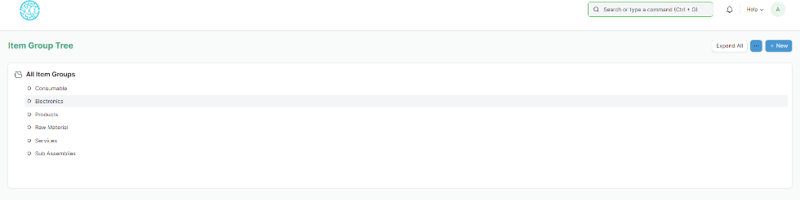

#### 1.2 Delete an Item Group

1. Select the Item Group you want to delete.
2. Select 'Delete'.
3. Click on Yes.

#### 1.3 Features

To see the following options, click on an Item Group, click on Edit.

#### 1.4 Parent Item Group

You can change the parent Item Group of an item by choosing another one under General Settings.

#### 1.5 Defaults

* Default Price List: A default price list that'll determine the Item Prices for this Item Group.
* Default Warehouse: Default Warehouse set in transactions for the items that belong to this group.
* Default Buying/Selling Cost Center: The default Buying/Selling Cost Center to which items in this group will be billed against.
* Default Expense/Income Account: The default accounts for items that belong to this group.
* Default Supplier: On setting a supplier here, this supplier will be chosen in purchase transactions by default for items in this group.

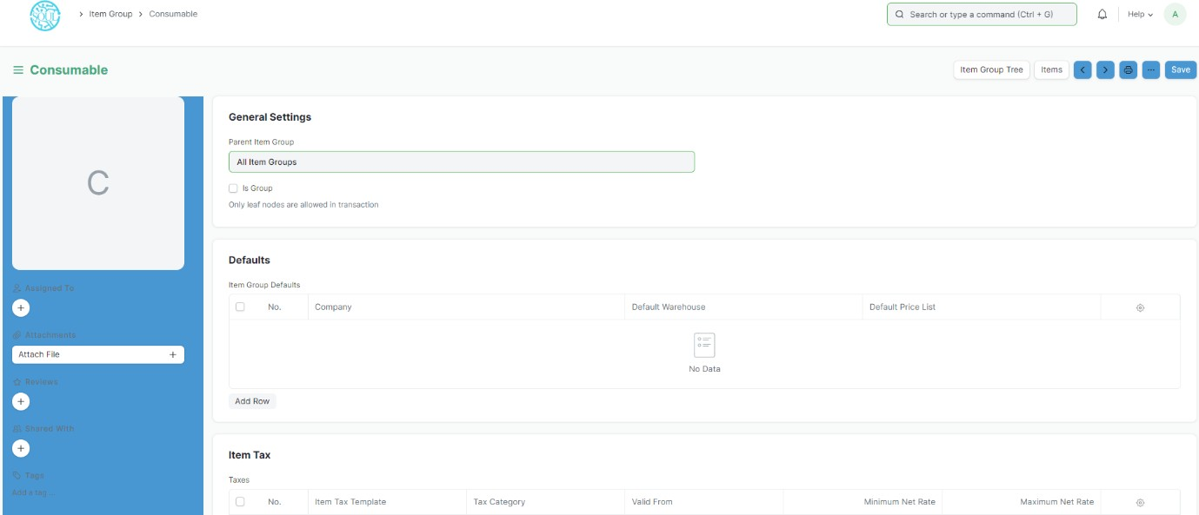

#### 1.6 Item Tax

A default item tax template will be applied to all items belonging to this group.

### Item

An Item is a product or a service offered by your company.

The term Item is also applicable to raw materials or components of products yet to be produced (before they can be sold to customers). EduLead allows you to manage all sorts of items, like raw-materials, sub-assemblies, finished goods, item variants, and service items.

EduLead is optimized for itemized management of your sales and purchase. If you are in services, you can create an Item for each service that you offer. Completing the Item Master is very essential for the successful implementation of EduLead.

To access the Item list, go to:

Home > Material Management > Items and Pricing > Item

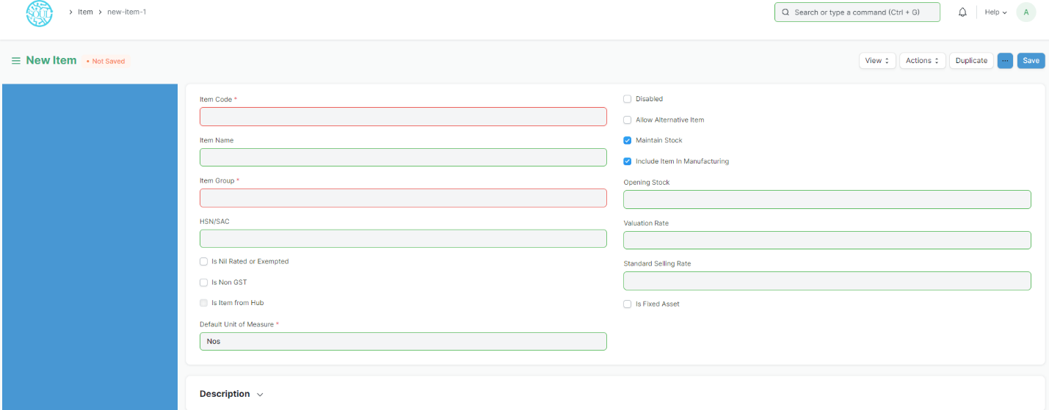

#### 2.1 Prerequisites

Before creating and using an Item, it is advised that you create the following first:

* Item Group
* Warehouse
* A Unit of Measure if required

#### 2.2 How to create an Item?

1. Go to the Item list, click on new.
2. Enter an Item Code, the name will be auto-filled the same as Item Code on clicking inside the Item Name field.
3. Select an Item Group.
4. Enter the opening stock units and standard selling rate.
5. Click on Save.

#### 2.3 Item Properties

* Item Name: Item name is the actual name of your product or service.
* Item Code: Item Code is a short-form to denote your Item. If you have very few Items, it is advisable to keep the Item Name and the Item Code same. This helps new users to recognize and update Item details in all transactions. In case you have a lot of Items with long names and the list runs in hundreds, it is advisable to code. To understand naming Item codes see Item Codification. You can also generate Item Code based on a Naming Series by enabling this feature in Stock Settings.
* Item Group: Item Group is used to categorize an Item under various criteria like products, raw materials, services, sub-assemblies, consumables or all Item groups. Create your default Item Group list under Setup > Item Group and pre-select the option while filling your New Item details under Item Group. Item groups can be sub- assemblies, raw materials, etc, or based on your business use case.
* Default Unit of Measure: This is the default measuring unit that you will use for your product. It could be Nos, Kgs, Meters, etc. You can store all the UOMs that your product will require under Set Up> Master Data > UOM. These can be pre-selected while filling New Item by using % sign to get a pop up of the UOM list. Visit the UoM page for more details

#### 2.4 Options when creating an item

* Disabled: If you disable an Item, it cannot be selected in any transaction.
* Maintain Stock: If you are maintaining stock of this Item in your Inventory, EduLead will make a stock ledger entry for each transaction of this item. Ensure to keep this option unchecked when creating a non-stock Item (make to order/engineer) or a service.
* Standard Selling Rate: When *creating* an Item, entering a value for this field will automatically create an Item Price at the backend. Entering a value after the Item has been saved will not work. In this case, the Item Price is created from any transactions with the Item. The rate at which you'll sell the item. This will be fetched in Sales Orders and Sales Invoices.
* Is Fixed Asset: Tick this checkbox if this item is a company Asset.
* Auto Create Assets on Purchase: If Item is a Company Asset, tick this checkbox if you want to auto create assets while purchasing this item through Purchase Cycle.
* Allowance Percentage: This option will be available only when you create and save the item. This is the percent by which you will be allowed to over-bill or over-deliver this Item. If not set, it will select from Stock Settings.
* Uploading an Image: To upload an image for your icon that will appear in all transactions, save the partially filled form. Only after your file is saved the 'Change' button will appear on the Image icon. Click on Change, then click on Upload, and upload the image.
* HSN/SAC: Harmonized System of Nomenclature (HSN) and Service Accounting Code (SAC) for GST. These numbers are defined by the government and different Items fall under different codes. New HSN codes can be added if not present in the list.
* Is nil rated or exempted: For an Item that is under GST, but no tax is applied to it. Eg: Cereals.
* Is Non GST: For an item that is not covered under GST. Eg: petrol.

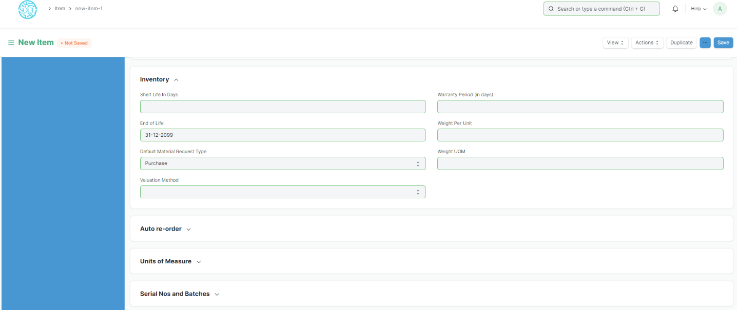

#### 2.5 Features

**2.5.1 Brand and Description**

* Brand: If you have more than one brand save them under Brand and pre-select them while filling a New Item.
* Description: Description of the item. The text from the Item Code will be fetched by default.

#### 2.5.2 Barcodes

Barcodes can be recorded in Items to quickly scan and add them in transactions. In the Barcodes table you can add an Item's barcode for scanning. There are two types of barcodes in EduLead:

* EAN: The European Article Number is a 13-digit number. EAN is used internationally and recognized by more POS systems.
* UPC: The Universal Product Code is a 12-digit number. UPC is generally used only in USA and Canada.

#### 2.5.3 Inventory

* Shelf Life In Days: This is for a product Batch. The number of days after which product batch will be unusable. For example, medicines.
* End of Life: For a single item/product, the date after which it'll be completely unusable. That is, the item will be unusable in transactions and manufacturing. For example, you're using plastic crystals for manufacturing Items for the next 5 years after which you want to use plastic beads.
* Warranty: To track a warranty period, it is necessary that the Item is serialized. When this Item is delivered, the delivery date and the expiry period is saved in the Serial Number master. Through the serial number master, you can track the warranty status.

A warranty period is a time period in which a purchased product may be returned or exchanged.

* Weight UOM: The Unit of Measure for the item. This can be Nos, Kilo, etc. The Weight UoM which you use internally can be different from the purchase UoM.
* Weight Per Unit: The actual weight per unit of the item. Eg: 1 kilo biscuits or 10 biscuits per pack.
* Default Material Request Type: When you create a new Material Request for this item, the field set here will be selected by default in the new Material Request. This is also known as an 'indent'.
* Valuation Method: Select the Valuation Method whether FIFO or Moving Average.

#### 2.5.4 Automatic Reordering

When the stock of an item dips under a certain quantity, you can set an automatic reorder under 'Auto Reorder' section. This should be enabled in Stock Settings. This will raise a Material Request for the Item. The user with roles Purchase Manager and Stock Manager will be notified when the Material Request is created.

* Check in (group): In which group warehouses to check the quantity of the item.
* Request for: Which warehouse to stock the item reorder.
* Re-order Level: When this quantity is reached, the reorder will be triggered. Re- order level can be determined based on the lead time and the average daily consumption. For example, you can set the reorder level of Motherboard at 10. When only 10 Motherboards are remaining in stock, the system will either automatically create a Material Request in your EduLead account.
* Re-order Qty: The number of units to be reordered so that the sum of ordering cost and holding cost is at its minimum. The re-order quantity is based on the 'Minimum Order Qty' specified by the supplier and many other factors. For example, If reorder level is 100 items, your reorder quantity may not necessarily be 100 items. The Reorder quantity can be greater than or equal to the reorder level. It may depend upon lead time, discount, transportation and average daily consumption.
* Material Request Type: The Material Request type with which the stock will be reordered. This depends whether you buy the Item, manufacture it yourself or transfer it between Warehouses.

Note: The Material Request is created at 12 midnight depending on the set reorder level.

#### 2.5.5 Multiple Units of Measure

You can add alternate UoMs for an Item. If the default UoM in which you sell is numbers (NoS) but you receive it in Kilos, you can set an additional UoM with an appropriate conversion factor. For example, 500 Nos of screws = 1 Kilogram, so select Kilogram/Litre as UOM and set the conversion factor as 500.

##### 2.5.6 Serial Numbers

With Serial Numbers, you can track warranty and returns. In case any individual Item is recalled by the supplier the number system helps to track individual Item. The numbering system also manages expiry dates.

Please note that if you sell your items in thousands, and if the items are very small like pens or erasers, you need not serialize them.

In EduLead, you will have to mention the Serial Number in some accounting entries. If your product is not a big consumer durable Item, if it has no warranty and has no chances of being recalled, avoid giving serial numbers.

##### 2.5.7 Batches

A set of Items can be manufactured in batches. This is useful for moving the batch and associate an expiry date with a certain batch.

* Has Batch No: Options for batch number, expiry date, and retaining sample stock will be revealed on ticking this checkbox. You cannot activate this if there is any pre-existing transaction for this item. If this is disabled, you'll have to enter the serial numbers manually for every transaction.
* Batch Number Series: Prefix that'll be applied to batch numbers. If you set 5x1SCR, then the first batch will be named like 5x1SCR00001 on first transaction/manufacture.
* Automatically Create New Batch: If the batch number is not mentioned in transactions, then they will be automatically created according to a format like AAAA.00001. If you always want to manually create a batch number for this item, leave this field blank. This setting will override 'Naming Series Prefix' in Stock Settings. Batch numbers can be set to be generated automatically if you manufacture the Items or can be entered manually if it comes from an external manufacturer.
* Has Expiry Date: If you tick this, the batch number will be created according to the expiry date. The expiry dates can be set in the 'Batch' master.
* Retain Sample: To retain a minimum number of sample stock of the item. You need to set a Sample Retention Warehouse in Stock Settings for this.
* Has Serial No: This is similar to Batch Number Series; it'll be created when you make transactions/manufacture. If you set Serial Number Series as AA, then on the first transaction a serial number like AA00001 will be created.

Tip: While entering an Item Code in an Items table, if the table requires inventory details, then depending on whether the entered item is batched or serialized, you can enter serial or batch numbers right away in a pop-up dialog.

Note: Once you mark an item as serialized or batched or neither, you cannot change it after you have made a Stock Entry.

##### 2.5.8 Item Defaults

In this section, you can define Company-wide transaction-related defaults for this Item.

* Default Warehouse: This is the Warehouse that is automatically selected in your transactions with this item.
* Default Price List: Whether Standard Selling or Standard Buying. Likewise, you can also set the purchasing and selling default accounts
* Supplier: If a default supplier is set, this supplier will be selected for new purchase transactions.
* Default Expense Account: It is the account in which cost of the Item will be debited.
* Default Income Account: It is the account in which income from selling the Item will be credited.
* Default Cost Center: It is used for tracking expense for this Item.

Tip: You can add more rows for multiple companies.

##### 2.5.9 Purchase, Replenishment Details

* Default Purchase Unit of Measure: The default UoM that will be used in Purchase transactions.
* Minimum Order Qty: The minimum quantity required for purchase transactions like Purchase Orders. If set, the system will not let you proceed with the purchase transaction if the item quantity in the purchase transaction is lesser than the quantity set in this field.
* Safety Stock: “Safety Stock” is used in the report “Item wise Recommended Reorder Level”. Based on Safety Stock, average daily consumption and the lead time, the system suggests Reorder Level of an item. Reorder Level = Safety Stock + (Average Daily Consumption * Lead Time)
* Last Purchase Rate: The rate at which you last purchased this item using a Purchase Invoice will be displayed here.
* Is Purchase Item: If un-ticked, you won't be able to use this item in purchase transactions.
* Is Customer Provided Item: Checked if Item is provided by a customer and received through Material Receipt. If Checked, Customer field is Mandatory as the default customer for Material Request.
* Lead time days: Lead time days are the number of days between ordering the Item and it to reach the Warehouse.

##### 2.5.10 Supplier Details

* Delivered by Supplier (Drop Ship): If the item is delivered directly by the supplier to the customer, tick this checkbox. Read more here.
* Supplier Codes: Track Item Code defined by the Suppliers for this Item. In the Purchase transactions, on selecting an Item, a Supplier Part No. will be fetched as well for the Supplier's reference. You can read more about it here.

##### 2.5.11 Foreign Trade Details

If you're sourcing the item from another country, you can set the details here.

* Country of Origin: The country from which you're sourcing the item.
* Customs Tariff Number: You can create a customs tariff number with a description and use it for reference here to share with custom agencies. Later it can be used to add in Delivery Notes.

##### 2.5.12 Deferred Revenue and Deferred Expense

You can enable deferred revenue or expense from the item. Once you tick the checkbox, you'll see options to set the Deferred Expense Account and the number of months through which the revenue/expense is deferred.

For example, consider a yearly gym membership, you pay the money upfront at once but the service is given throughout the year. For the gym owner, this is deferred revenue and for the customer, it is a deferred expense.

##### 2.5.13 Customer Details

The Customer may identify an Item with a different Item Code. this is Similar to Supplier Code.

* Customer Name: Select a customer here.
* Customer Group: This will be fetched based on the Customer you selected in the previous field.
* Ref Code: A customer can identify this item with a different number. You can track Item Code assigned by the Customer for this Item. When you create a Sales Order, the Customer's Reference Code for this Item will be shown.

##### 2.5.14 Item Tax

These settings are required only if a particular Item has a different tax rate than the rate defined in the standard tax Account.

You need to create a new 'Item Tax Template' or choose an existing one. For example, if you have a tax Account, “VAT 14%” and this particular Item is exempted from tax, then you select “VAT 14%” in the first column, and set “0” as the tax rate in the second column. Visit the Item Tax Template page for more details.

You can also set a Tax Category for this Item.

##### 2.5.15 Inspection Criteria

* Inspection Required before Purchase: If an inspection is mandatory before the item is purchased, i.e., before you generate Purchase Receipt, tick this checkbox.
* Inspection Required before Delivery: If an inspection is required at the time of delivery from your Supplier is mandatory for this Item, tick this checkbox. That is, before you generate a Delivery Note.
* Quality Inspection Template: If a Quality Inspection is prepared for this Item, then this template of criteria will automatically be updated in the Quality Inspection table of the Quality Inspection. Examples of Criteria are: Weight, Length, Finish, etc.
* Quality Inspection can be done with Quick View and you need not go to a different page to update the details inspection in EduLead.

### Item Price

Item Price is the record in which you can log the selling and buying rate of an item.

#### 3.1 How to create Item Price

1. Go to Item Price list and Click on New.
2. Select the Item. The name, UoM and description will be fetched.
3. Select the Price List whether Selling/Buying price or any other price list you may have created.
4. Enter the actual rate in the Rate field.
5. Click on Save

Home > Material Management > Items & Pricing > Item Price

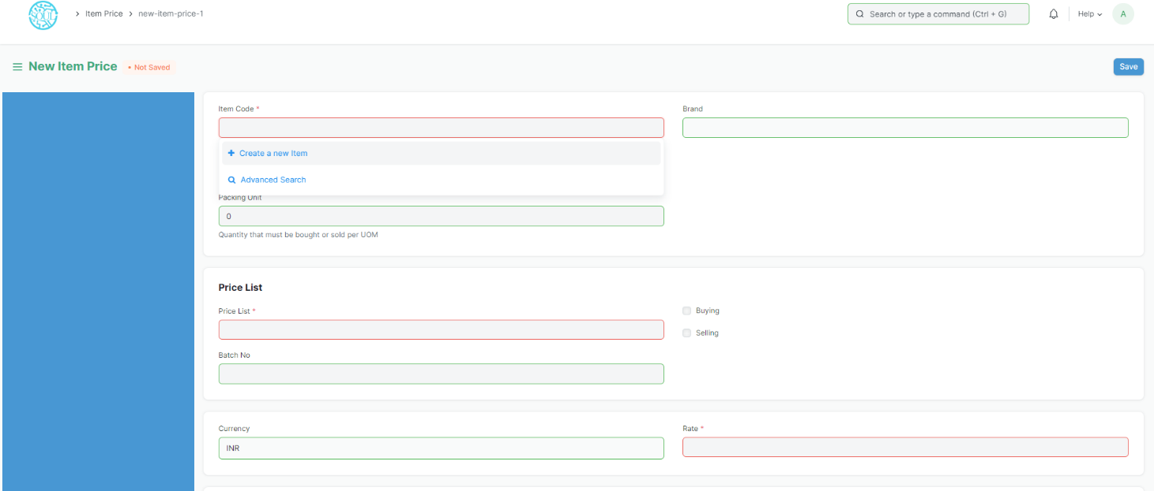

#### 3.2 Selecting the Price List

You can create multiple Price Lists for one Item in EduLead to track Selling and Buying Price of an Item separately. Also if the Item's selling prices change based on Territory or due to other criteria, you can create multiple Selling Price Lists for it.

On selection of Price List, its currency and applicability whether for selling/buying or both will be fetched as well. To have Item Price fetching in the sales or purchase transaction, you should have 'Price List' selected in the transaction under Currency and Price List.

#### 3.3 Features

**3.3.1 Packing Unit**

This is the quantity that must be bought or sold per unit of measure. For example, if Packing Unit is two, and UOM is one, two items in quantity will be transacted. The default is 0, you can use non-integer UoM like 1.5Kg Oats for 1 Packing Unit. If you leave it as 0, it'll not affect any transaction.

##### **3.3.2** Minimum quantity

This is the minimum quantity of items to be transacted for this price to be applicable and updated in the Item Price list.

##### **3.3.3** Applying Price List to a specific Customer/Supplier

If you select a Selling Price list, a customer field will appear where you can assign this Item Price to a specific customer. Likewise, if you select a Buying Price List, a Supplier field will appear where you can select a specific Supplier

##### **3.3.4** Applying Price List to a specific Batch

You can also link a specific batch to an Item Price and on the selection of that batch in the transaction, the item price for that specific batch will be applied.

##### **3.3.5** Validity

There are two fields here—'Valid From' and 'Valid Upto'. Valid from is set to the date you created the Item Price, you can also set the Valid Upto date on which the Item Price will expire.

##### **3.3.6** Lead Time in days

The approximate number of days it takes the product to reach the warehouse. You can set different Item Prices based on how much time the same product will reach you from different vendors.

##### **3.3.7** Note

You can add any note about the Item Price in this field.

1. **Price List**

**A Price List is a collection of Item Prices either Selling, Buying, or both. User** maintain multiple Selling and Buying [Item Prices](https://docs.erpnext.com/docs/v13/user/manual/en/stock/item-price) using Price Lists.

Home > Material Management > Items and Pricing > Price List

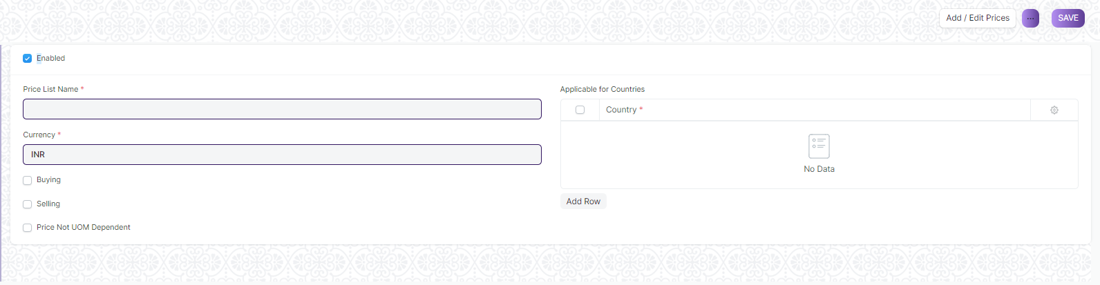

#### 4.1 How to create Price List

1. Price Lists will be used when creating an [Item Prices](https://docs.erpnext.com/docs/v13/user/manual/en/stock/item-price) to track selling or buying price of an item.
2. Specific countries can be assigned in the Price List.
3. To disable specific Price List, un-tick the 'Enabled' checkbox. Disabled Price List will not be available for selection in the Sales and Purchase transactions.
4. ****Price Not UOM Dependent****: Consider an item, Tomatoes which you buy in Boxes and sell in Kilos. 1 Box = 10 Kilos and 1 Kilo buying price is 10rs. If this Box is unchecked and you select 1 Box in your transaction, the price will show up only for a Kilo since that's the only Item Price saved.
5. Now, if you tick this checkbox and make a transaction with a Box of Tomatoes, then the price will be automatically set as 100 since the price of 1 Box (10 Kilos) is 100.
6. Standard Buying and Selling Price Lists are created by default.

****Note****: If you have multiple Price Lists, you can select a Price List or tag it to a customer (so that it is auto-selected). Your Item Prices will automatically be updated from the Price List.

1. **Supplier**

**Suppliers are companies or individuals who provide you with products or services.**

Home > Material Management > Supplier > Supplier

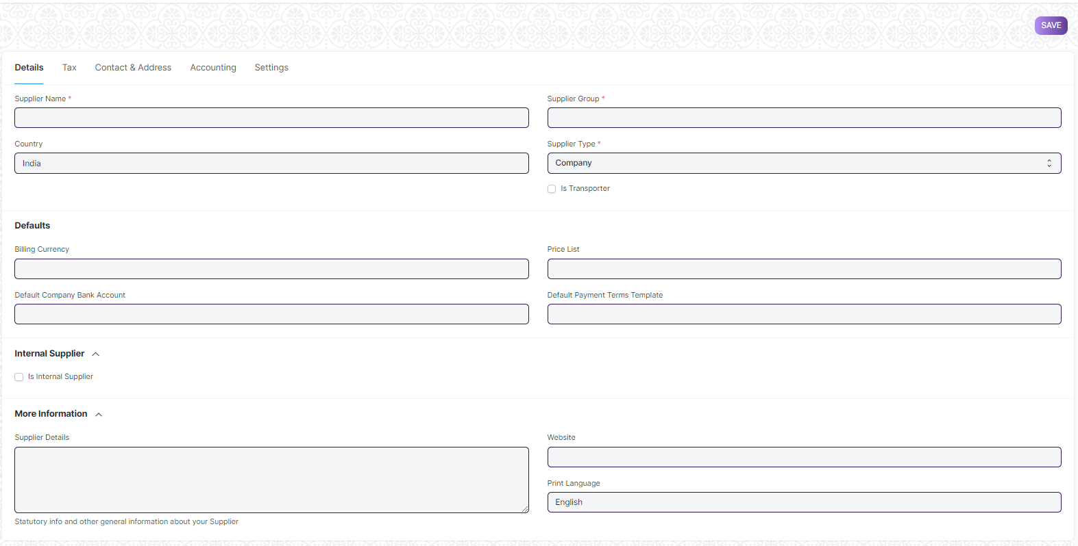

#### 5.1 How to create Supplier List

1. Go to the Supplier list and click on New.
2. Enter a name for the supplier.
3. Select the supplier group whether Pharmaceutical, Hardware etc.
4. User will maintain Supplier Contact and address and also can block.
5. Click on Save.

#### 5.2 **Features**

Fields in future transactions will be auto-populated if the 'Default' fields like Default Bank Account, Default Payment Terms Template etc., are set in Supplier.

### **5.2.1 Tax details**

1. ****Country****: If the supplier is from another country, you can change it here.
2. ****Tax ID****: Tax identification number of the supplier.
3. ****Tax Category****: This is linked to [Tax Rule](https://docs.erpnext.com/docs/v13/user/manual/en/accounts/tax-rule). If a Tax Category is set here, when you select this supplier, the respective Purchase Tax and Charges template will be applied. This template is linked to the Tax Rule and the Tax Rule is linked with a Tax Category. Tax Category can be used to group suppliers to whom same tax will be applied. For example: Government, commercial, etc,.
4. ****Print Language****: The language in which the document will be printed.
5. ****Tax Withholding Category****: For India, TDS category for the Supplier. On setting a category here, it will be fetched into the [Purchase Invoice](https://docs.erpnext.com/docs/v13/user/manual/en/accounts/purchase-invoice). For more information, visit the [Tax Withholding Category](https://docs.erpnext.com/docs/v13/user/manual/en/accounts/tax-withholding-category) page.
6. ****Disabled****: Disables the Supplier and they won't be shown in the Supplier List.
7. ****Is Transporter****: If the supplier is selling your transport services, tick this box. 'GST Transporter ID' field will be visible if this field is ticked.
8. ****Internal Supplier****: If the supplier is from a sister or parent/child company, tick this field and select the company which they represent.

For India:

1. ****GST Category****: Select a GST Category of the supplier.
2. ****PAN****: For India, PAN (Permanent Account Number) card details of the Supplier.

### **5.2.2 Allow creation of Purchase Invoice without Purchase Order and Purchase Receipt**

If the "Purchase Order Required" or "Purchase Receipt Required" option is configured as "Yes" in [Buying Settings](https://docs.erpnext.com/docs/v13/user/manual/en/buying/buying-settings), it can be overridden for a particular supplier by enabling the "Allow Purchase Invoice Creation Without Purchase Order" or "Allow Purchase Invoice Creation Without Purchase Receipt" in the Supplier Master.

### **5.2.3 Currency and Price List**

****Billing Currency****: Your supplier's currency can be different from your company currency. If you choose JPY for a supplier, then the currency will be filled as JPY and the exchange rate shown for future purchase transactions.

1. **Supplier Group**

**Supplier Group is an aggregation of suppliers that are similar in some way.**

Home > Material Management > Supplier > Supplier Group

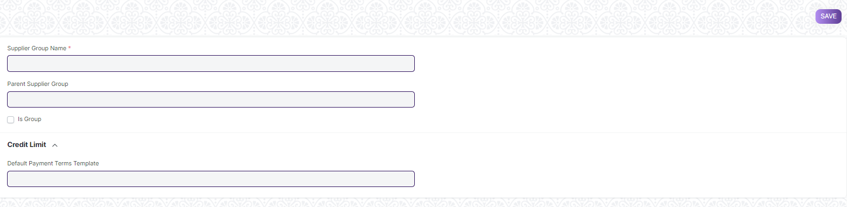

#### 6.1 Prerequisites

* Supplier

#### 6.2 How to create Supplier Group List

1. Go to the Supplier Group list, click on New.
2. Type a name for your new Supplier Category.
3. You can set a Parent Supplier Group for this Supplier Group.
4. Ticking the Is Group checkbox will make it a Parent Supplier Group.
5. You can also assign a default Payment Terms Template to the Supplier Group. Useful in a case where all your hardware suppliers take half payment on sales order and half post shipment.
6. Click on Save.
7. **Warehouse**

A warehouse is a commercial building for the storage of goods. Warehouses are used by manufacturers, importers, exporters, wholesalers, transport businesses, customs, etc.

They are usually large plain buildings in industrial areas of cities, towns, and villages. They mostly have loading docks to load and unload goods from trucks.

The terminology of 'Warehouse' in EduLead is a bit broader though and maybe can be regarded as "storage locations". You can create a sub-Warehouse which could be a shelf inside your actual location.

To access the Warehouse list, go to:

Home > Material Management> Settings > Warehouse

#### 7.1 How to create a Warehouse

1. Go to the Warehouse list, click on New.
2. Enter a name for the Warehouse.
3. Set/check the Parent Warehouse. If you tick on 'Is Group', you can create sub- Warehouses under this group Warehouse.
4. Click on Save.

Warehouses are saved with their respective company’s abbreviations. This facilitates identifying which warehouse belongs to which company at a glance.

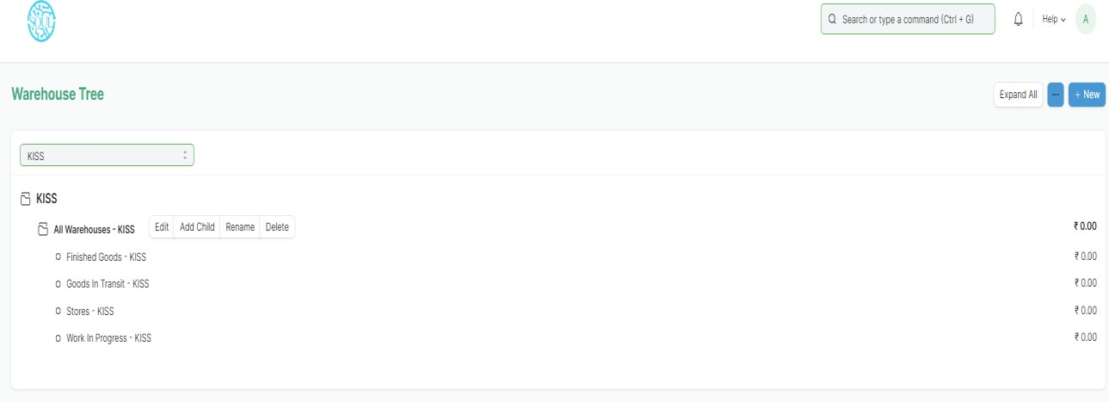

##### 7.1.1 Additional options when creating a Warehouse

**Account:** Set a default account here for all transactions with this Warehouse. Setting this account will show transactions from this Warehouse in the Accounting Ledger. Warehouse Type: You can create a Warehouse Type to classify Warehouses. For example, Supplier Warehouses, Stock Warehouses, WIP Warehouses, Rooms, etc. can be tagged. This classification is useful when generating reports or in certain stock transactions.

**Address and contact:** You can add Billing, Shipping, and other types of addresses for the Warehouse. You can also add a contact; this could be the Warehouse Manager for example

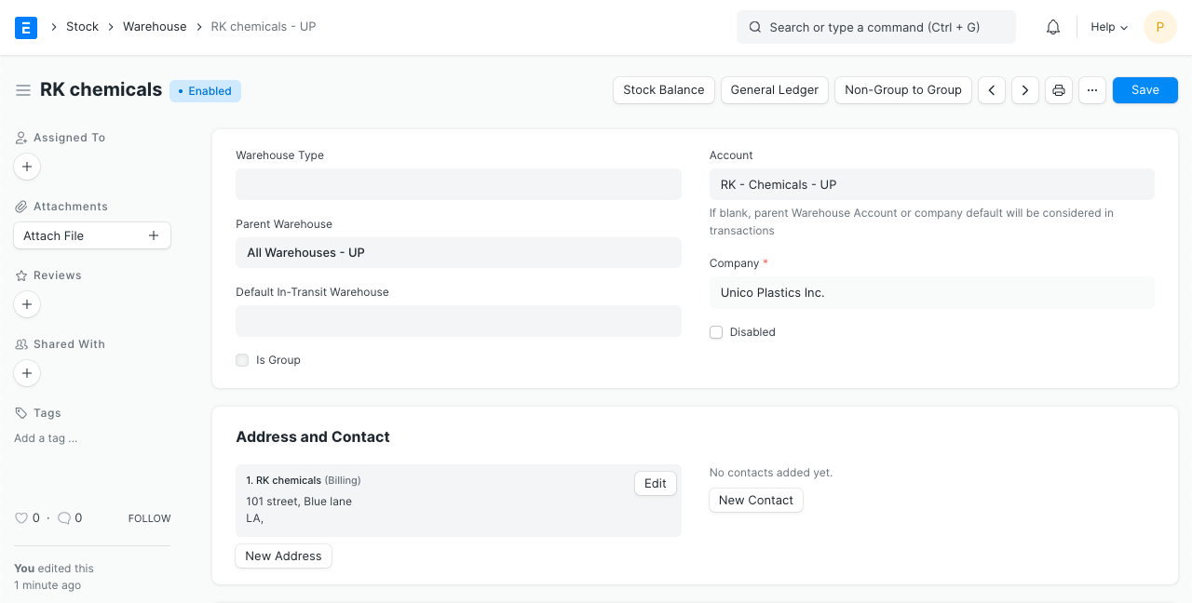

##### 7.1.2 After Saving

After saving a Warehouse, you'll see the following options:

* Stock Balance: This will open the Stock Balance report to display the quantity, valuation, balance, etc.
* General Ledger: This will open the General Ledger to display the accounting transactions.
* Non-Group to Group: If the Warehouse is a Non-Group Warehouse, i.e. cannot contain other Warehouses under it, this button will make this a Group Warehouse.

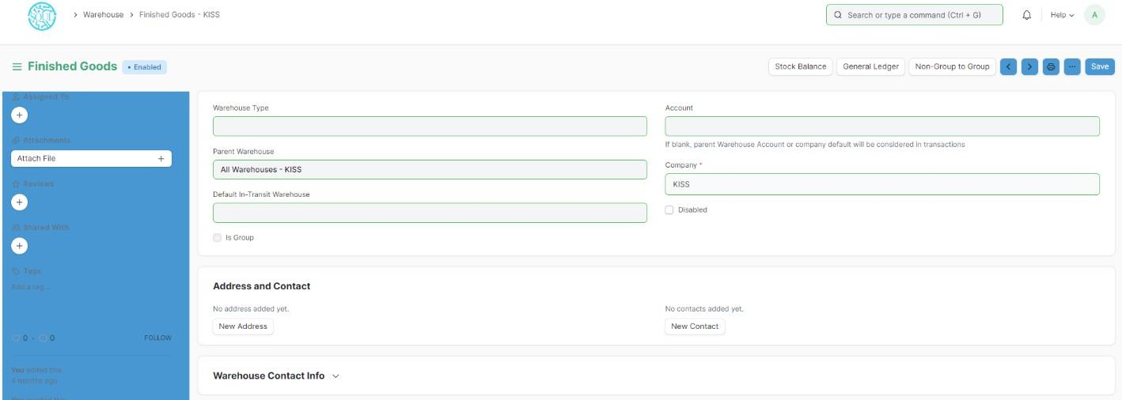

**7.2 Features**

##### 7.2.1 Tree View

You can also switch to 'Tree' View which will show all the group and child Warehouses.

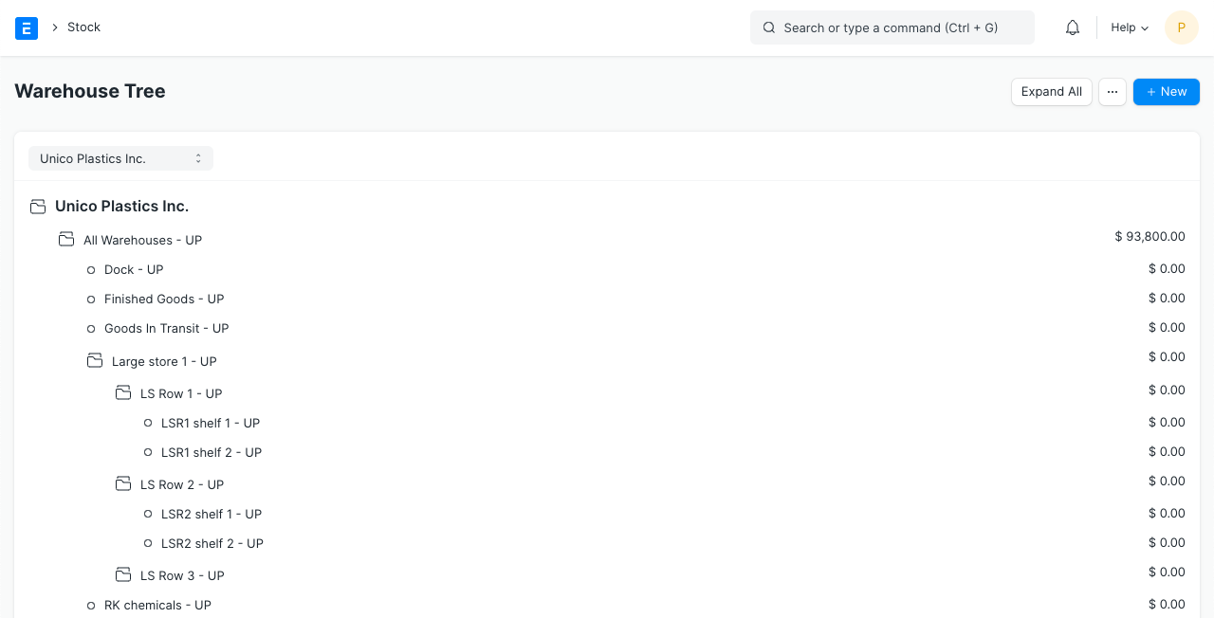

##### 7.2.2 Warehouse Account

In EduLead, if you enable Perpetual Inventory, every Warehouse must belong to a specific company to maintain company-wise stock balance. To do so, each Warehouse should be linked with an Account in the Chart of Accounts (the same name as the Warehouse itself). This account captures the monetary equivalent of the goods or materials stored in that specific warehouse.

If you have a more detailed Warehouse Tree, most likely it's a good idea to link the sub- locations (room, row, shelf, etc.) to the account of the actual Warehouse (the root Warehouse of that Tree) as most scenarios do not require to account for value of stock items per Shelf or Bin. For example, if you have Warehouse A, and the room, rows are B, C, etc., then link B and C to the account of A.

Tip: EduLead maintains stock balance for every distinct combination of Item and Warehouse. Thus you can get the stock balance for any specific Item in a particular Warehouse on any particular date.

1. **Unit of Measure (UoM)**

**A UoM is a unit using which an Item is measured.**By default, there are many UoMs created in form. However, more can be added depending on your business use case. In the UoM there is an option 'Must be Whole Number'. If this is checked, you cannot use fraction numbers in this UoM.

Home > Material Management> Settings > Unit of Measure (UoM)

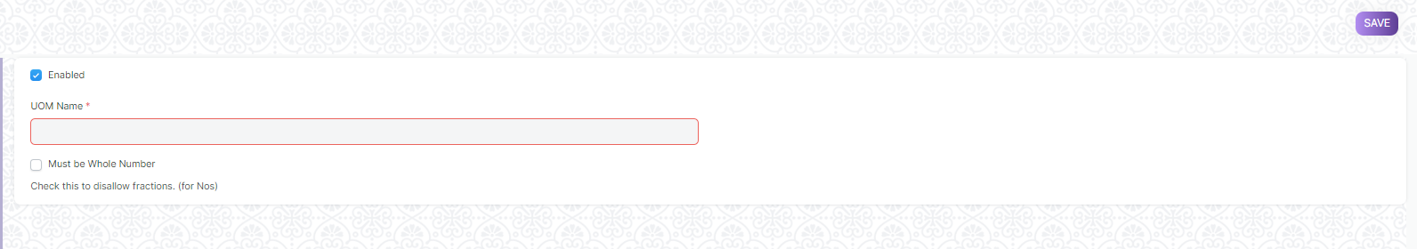

1. **Purchase Taxes and Charges Template**

**Purchase Taxes and Charges may be applied to any item you buy.**

Home > Material Management> Settings > Purchase Taxes and Charges Template

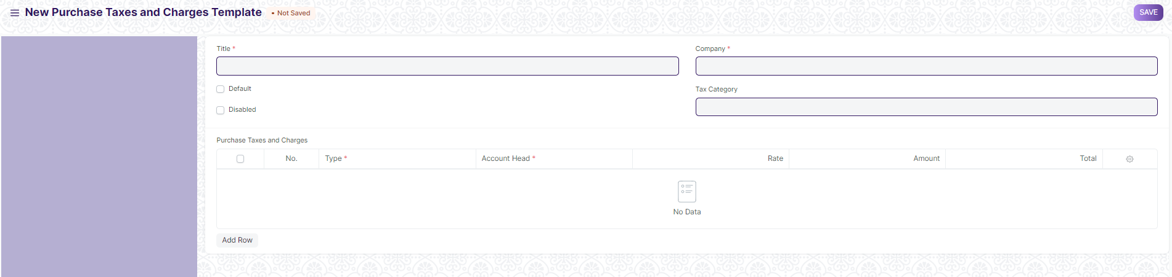

#### 9.1 How to create Purchase Taxes and Charges Template

1. Click on New.
2. Enter a title name for the Tax.
3. Under type, set on what the tax will be calculated and the tax rate. There are five options under type for which tax will be calculated.
   1. Actual: On the actual amount of each item.
   2. On Net Total: On the grand total of all the items.
   3. On Previous Row Amount: This is for compounding the charges. For example, cess charges over the amount to which tax was already applied in the previous row.
   4. On Previous Row Total: Same as above but applied on the total bill and not just the amount of an item.
4. Select an account head which has pre-set tax rates or create your own.
5. Selecting default will apply this template by default for new Purchase transactions.
6. Click on Save.

### **9.2 Purchase Taxes and Charges table**

* ****Consider Tax or Charge for****: Total - for the total of all items. Valuation - for each item. Valuation and total - apply tax/charge to both.
* ****Add or Deduct:**** Whether you want to add or deduct the tax from the item
* ****Reference Row #****: If tax is based on "Previous Row Total" you can select the row number which will be taken as a base for this calculation (default is the previous row).
* ****Is this Tax included in Basic Rate?****: If checked, the tax amount will be considered as already included in the Print Rate / Print Amount.
* ****Account Head:**** The Account ledger under which this tax will be booked. If you select VAT or any other preset heads, the rate will be automatically filled.
* ****Cost Center:**** If the tax/charge is an income (like shipping) or expense it needs to be booked against a Cost Center.
* ****Description:**** Description of the tax (that will be printed in invoices/quotes).
* ****Rate:**** The Tax rate, eg: 14 = 14% tax.
* ****Amount:**** The Tax amount to be applied, eg: 100.00 = ₹100 tax.

1. **Terms and Conditions**

**Terms and conditions contain the terms and conditions of a service/product offered by a seller to a buyer.**

Home > Material Management> Settings > Terms and Conditions

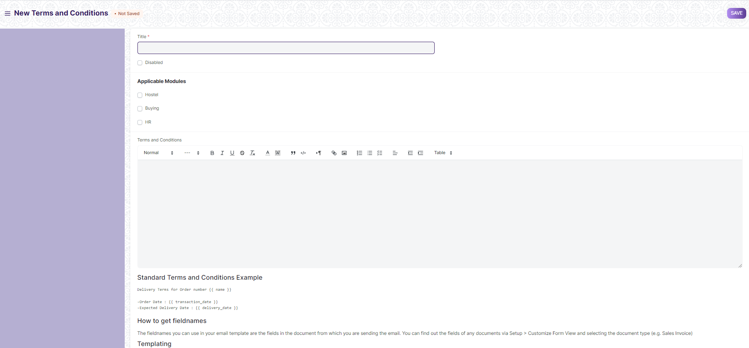

#### 10.1 How to create Terms and Conditions

1. Go to the Terms and Conditions Template list, click on New.
2. Add the Terms and Conditions.
3. **Buying Settings**

Buying Settings is where you can define properties which will be applied in the Buying

module's transactions.

Home > Material Management > Settings > Buying Setting

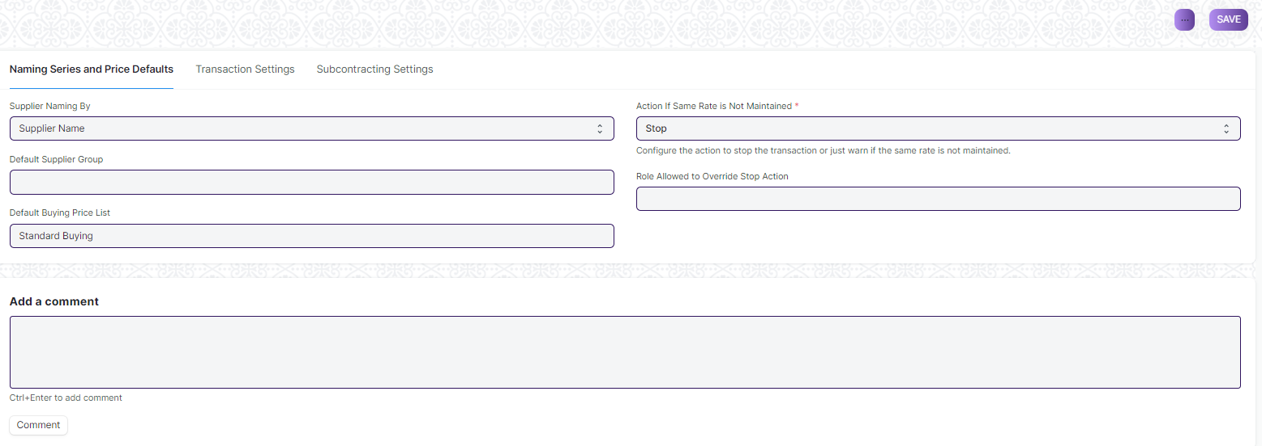

1. **Payment Terms Template**

**Payment Terms Template allow you to club multiple payment terms together and fetch in**

**transactions.**

Home > Material Management > Settings > Payment Terms Template

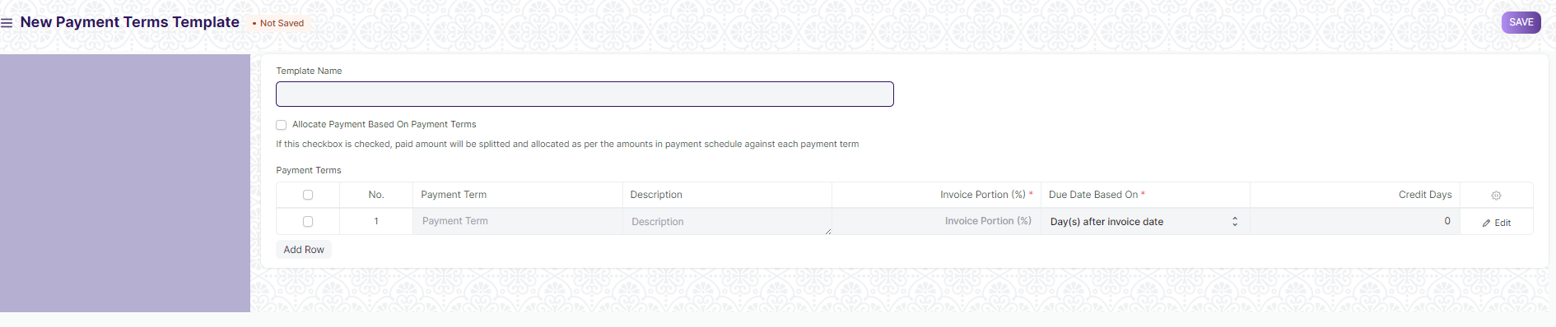

#### 12.1 Prerequisites

Payment Terms

#### 12.2 How to create Payment Terms Template

1. Go to the Payment Term Template list and click on New.
2. Enter a name for the template.
3. Add the created Payment Terms in the table rows.
4. Make sure that the total Invoice Portion adds up to 100.
5. Click on Save.
6. **Tax Withholding Category**

**Tax Withholding Category is Tax Deducted at Source.**

Home > Material Management > Settings > Tax Withholding Category

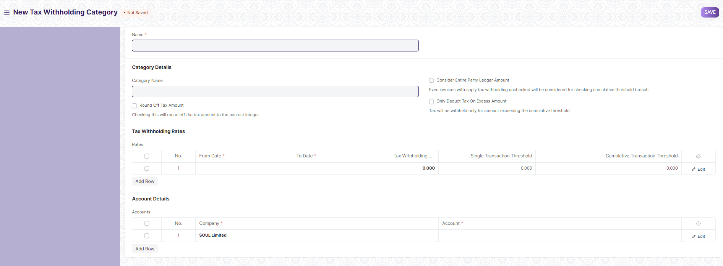

#### 13.1 Prerequisites

1. Supplier
2. Customer

#### 13.2 How to create Tax Withholding Category

1. Go to the Tax Withholding Category list and click on New.
2. Enter a unique name.
3. Enter a Category Name (Dividends, Professional Fees, etc,.).
4. Enter a Tax Withholding Rate against a [Fiscal Year](https://docs.erpnext.com/docs/v13/user/manual/en/accounts/fiscal-year).
5. You can set the threshold for a single invoice or sum of all invoices.
6. Select an account against your Company to which tax will be credited.
7. Add more companies and accounts as needed.
8. Click on Save.
9. **Quality Inspection Template**

User can mark your incoming or outgoing products for Quality Inspection.

Home > Material Management > Quality Inspection > Quality Inspection Template

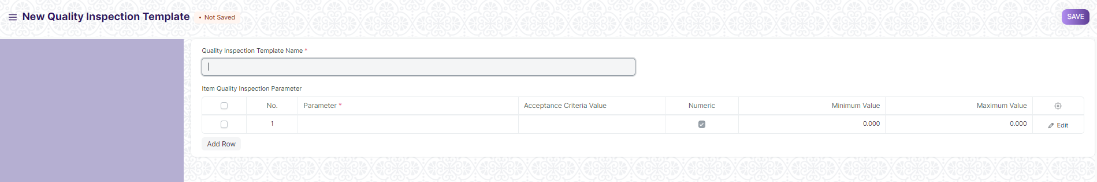

#### 14.1 Prerequisites

* **Quality Inspection Parameter**

#### 14.2 How to create Quality Inspection Template

1. Go to Quality Inspection template and click on New
2. Enter Template name
3. Enter Parameter and acceptance value and all details
4. Click on Save
5. **Quality Inspection Parameter**

Quality Inspection Parameter is master Screen for Quality Inspection Template.

Home > Material Management > Quality Inspection > Quality Inspection Parameter

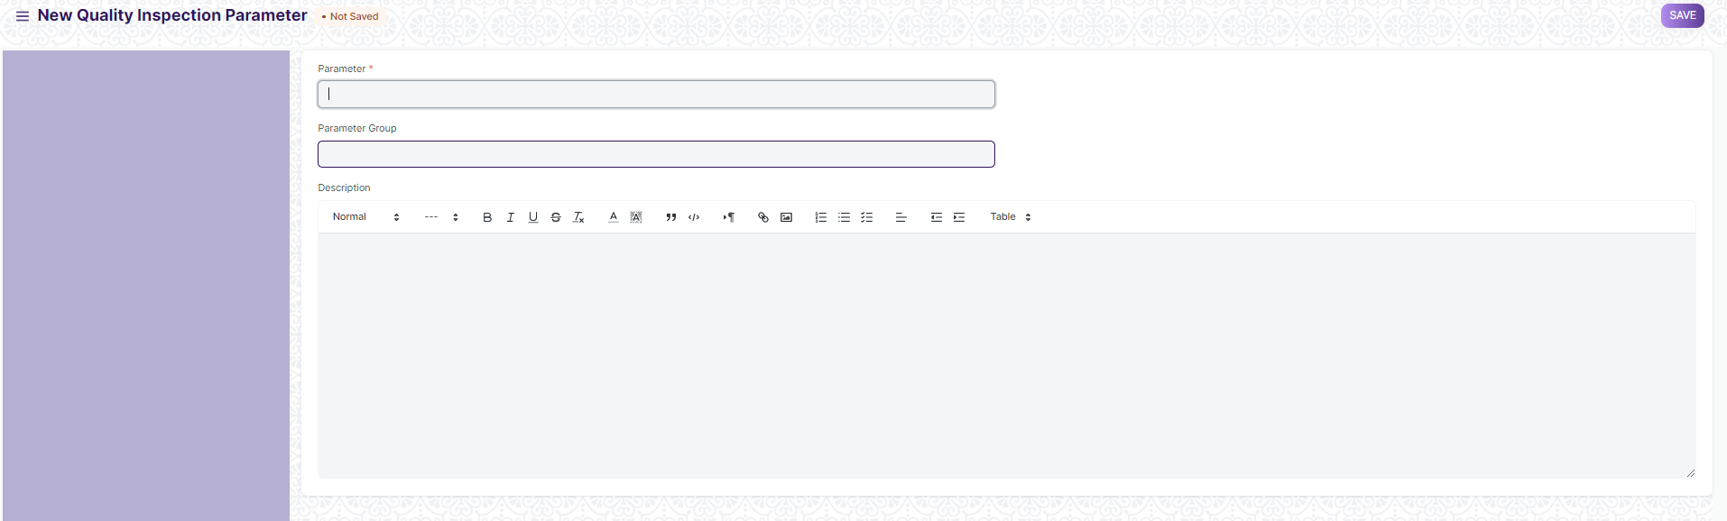

#### 15.1 Prerequisites

* **Quality Inspection Parameter Group**

#### 15.2 How to create Quality Inspection Template

1. Go to Quality Inspection Parameter and click on New
2. Enter Parameter Name and parameter group
3. Add description
4. Click on Save
5. **Material Request**

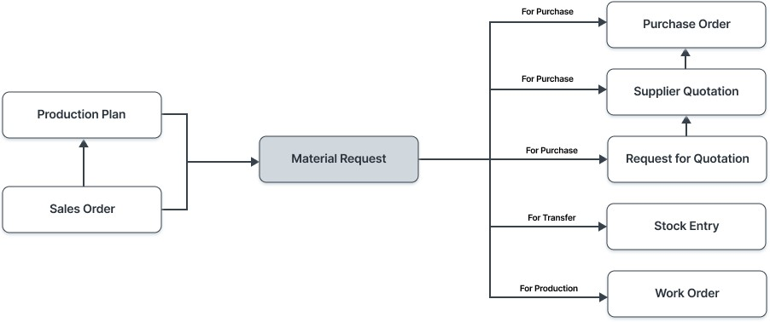

A Material Request is a simple document identifying a requirement of a set of items (products or services) for a particular reason.

A Material Request can have the following purposes:

* **Purchase**: If the material being requested is to be purchased.
* **Material Transfer**: If the material being requested is to be shifted from one Warehouse to another.
* **Material Issue**: If the material being requested is to be Issued for some purpose like manufacturing.
* **Manufacture:** If the material being requested is to be produced.
* **Customer Provided**: If the material being requested is to be provided by the customer.

To access the Material Request list, go to:

Home > Material Management > Buying > Material Request

**16.1 How to create a Material Request**

1. Go to the Material Request list, click on New.
2. Enter the required by date.
3. Select from one of the purposes as listed above.
4. You can fetch Items from a BOM, Sales Order, or Product Bundle.
5. Select the Item and set the quantity.
6. Select the Warehouse for which Items are required.
7. You can change the Required By date for individual Items in this table.
8. Click on Save and Submit.

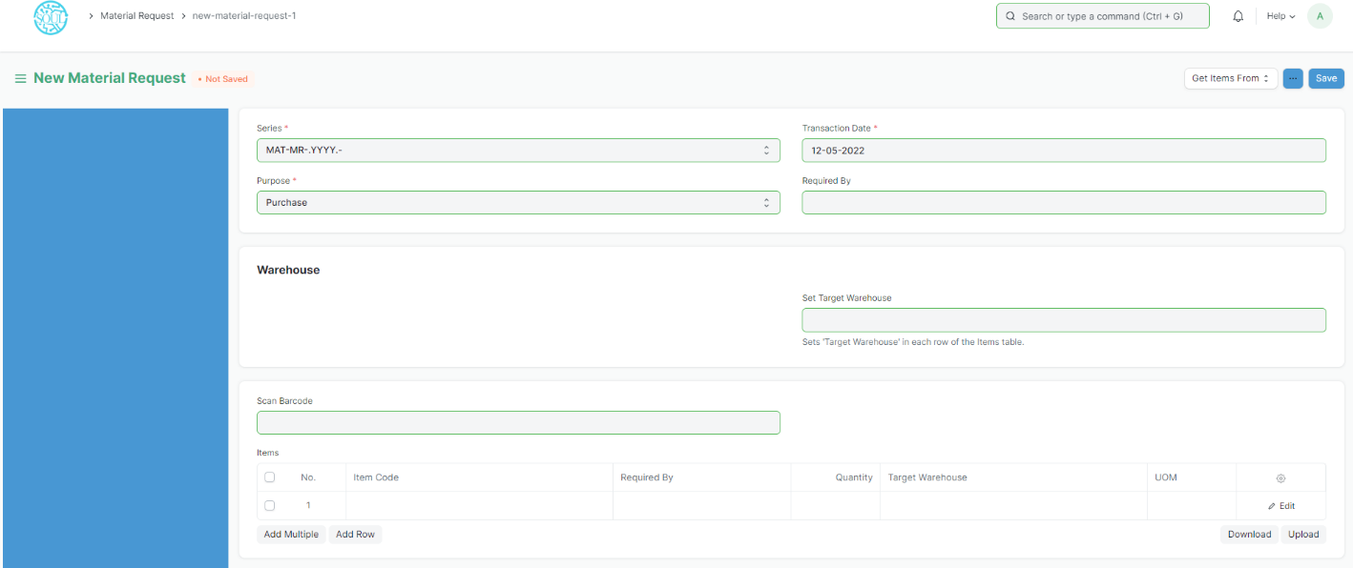

#### 16.2 Alternate ways of creating a Material Request

A Material Request can be generated automatically:

* From a Sales Order.
* When the Projected Quantity of an Item in Stores (Warehouses) reaches a particular level.
* From there, a Production Plan to plan your manufacturing activities.

If your Items are inventory items, you must also mention the Warehouse where you expect these Items to be delivered. This helps to keep track of the Projected Quantity for this Item.

Info: Material Request is not mandatory. It is ideal if you have centralized buying so that you can collect this information from various departments.

#### 16.3 Statuses

These are the statuses a Material Request can be in:

* **Draft**: A draft is saved but yet to be submitted to the system.
* **Submitted**: Document is submitted to the system.
* **Stopped**: If no more materials are needed the Material Request can be stopped.
* **Canceled**: The materials are not needed at all and the request is canceled.
* **Pending**: The Purchase/Manufacture is pending to complete the Material Request.
* **Partially Ordered**: Purchase Orders for some Items from the Material Request are made and some are pending.
* **Ordered**: All Items in the Material Request are ordered via Purchase Orders.
* **Issued**: The materials are issued using a Material Issue Stock Entry.
* **Transferred**: The required materials are transferred from one Warehouse to another using a Stock Entry.
* **Received**: The materials were ordered and have been received at your Warehouse using a Purchase Receipt.

#### 16.4 Features

**16.4.1 Items table**

* **Barcode**: You can track Items using bar codes.
* The Item Code, name, description, Image, and Manufacturer will be fetched from the Item master.
* **Scan Barcode**: You can add Items in the Items table by scanning their barcodes if you have a barcode scanner.
* The UoM, Conversion Factor, and Amount will be fetched. You change the Warehouse for which the material is being requested.
* Accounting details like Expense Account and Accounting Dimensions can be set for the Items.
* Page Break will create a page break just before this item when printing.

##### 16.4.2 Setting Warehouses

* **Set Warehouse**: Optionally, you can set the Warehouse where the requested Items will arrive. This will be fetched into the 'For Warehouse' fields in the Item table rows.

##### 16.4.3 More Information

In the 'Requested For' field, you can set a Reference from where Material Request was generated

##### 16.4.4 Terms and Conditions

In Sales/Purchase transactions there might be certain Terms and Conditions based on which the Supplier provides goods or services to the Customer. You can apply the Terms and Conditions to transactions to transactions and they will appear when printing the document.

##### 16.4.5 After Submitting

You can create the following documents:

* Request for Quotation
* Purchase Order
* Supplier Quotation

##### 16.5 Automatically generate Material Requests

Material Requests can be generated automatically by enabling the setting in Stock Settings and setting the level in the Item form. When the stock level dips below a certain quantity, setting a reorder will automatically create material requests for the Item.

1. **Request for quotation**

A Request for Quotation is a document that an organisation sends to one or more suppliers asking for a quotation for items.

#### 17.1 How to create a Request for Quotation

1. Go to the Request for Quotation list, click on New.
2. Enter the date.
3. Choose the Supplier to whom the Request for Quotation is to be sent.
4. In the next table, enter items, quantity and the target warehouse where you'll be sending the items.
5. Warehouses can be left blank if 'Maintain Stock' is unticked for the item.
6. Save and submit.

A Request for Quotation (RFQ) can also be created from a submitted Material Request. Once an RFQ is created, you can print and send suppliers the PDF which will have all the details you entered relevant to the RFQ.

1. **Supplier quotation**

After creation of Request for Quotation, there are two ways to generate Supplier Quotation from Request for Quotation.

#### 18.1 Creating a Supplier Quotation

1. Open Request for Quotation and click on Supplier Quotation > Create.
2. Select the Supplier, click on the supplier again. In this page, click on the + next to 'Supplier Quotation'. A new Supplier Quotation page will be opened, the user has to enter the quantity, rate and submit it.
3. ****Purchase Order****

A Purchase Order is a binding contract with your Supplier that you promise to buy a set of items under given conditions.

Home > Material Management > Buying > Purchase Order

#### 19.1 Prerequisites

Before creating and using a Purchase Order, it is advised that you create the following first:

* Supplier
* Item

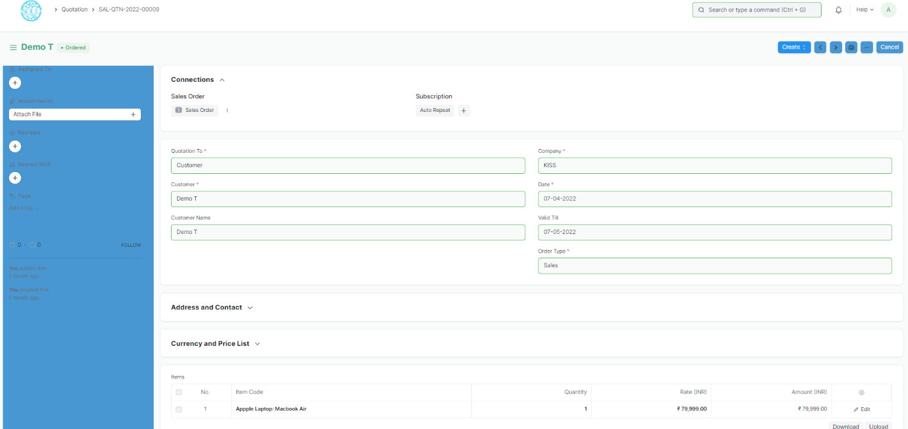

#### 19.2 How to create a Purchase Order?

A Purchase Order can be automatically created from a Material Request or Supplier Quotation.

1. Go to the Purchase Order list, click on New.
2. Select the Supplier, required by date.
3. In the items table, select the item by code, you can change the required by date for each item.
4. Set the quantity and the price will be fetched automatically if set in the Item master.
5. Set taxes.
6. Click on Save and Submit

#### 19.3 Setting Warehouses

* Set Target Warehouse: Optionally, you can set the default target Warehouse where the purchased Items will be delivered. This will be fetched into the Item table rows.

##### **19.4 Fetching Items from Open Material Requests**

Items can be fetched into the Purchase Order automatically from open Material Requests. For this to work, the following steps need to be done:

1. Select a Supplier in the Purchase Order.
2. Set default Supplier in the Item form under Item Defaults.
3. A Material Request needs to be present of type 'Purchase'.
4. Click on the Get Items from open Material Requests button below the Supplier name.
5. Now a dialog will appear with Material Requests containing Items for which the default Supplier is the same as the one selected in the Purchase Order.
6. On selecting the Material Requests and clicking on Get Items, the Items will be fetched from the Material Requests.
7. **Purchase Receipt**

Purchase Receipts are made when you accept Items from your Supplier usually against a Purchase Order.

You can also accept Purchase Receipts directly without the need for a Purchase Order. To do this, set Purchase Order Required as “No” in Buying Settings.

#### 20.1 To access the Purchase Receipt list, go to:

Home > Material Management > Buying > Purchase Receipt.

#### 20.2 Prerequisites

Before creating and using a Purchase Receipt, it is advised that you create the following first:

* Purchase Order

#### 20.3 How to create a Purchase Receipt

A Purchase Receipt is usually created from a Purchase Order. In the Purchase Order, click on Create > Purchase Receipt.

To create a Purchase Receipt *manually* (not recommended), follow these steps:

1. Go to the Purchase Receipt list, click on New.
2. The Supplier name and the Items can be fetched from the Purchase Order by clicking on 'Get Items from > Purchase Order'.
3. You can set the Accepted Warehouse for all items in this Purchase Receipt. This is fetched if set in Purchase Order.
4. In case any Items are defective, set the Rejected Warehouse where those Items will be stored.
5. Select the Item and enter the quantity in the Items table.
6. The rate will be fetched and the amount will be calculated automatically.
7. You can expand the item row to change the Accepted Warehouse for an Item.
8. Click on Save and submit.

#### 20.4 Statuses of Purchase Order

These are the statuses a Purchase Receipt can be in:

* Draft: A draft is saved but yet to be submitted to the system.
* To Bill: Yet to be billed using a Purchase Invoice.
* Completed: Submitted and received all the Items.
* Return Issued: All the Items have been returned.
* Cancelled: Cancelled the Purchase Receipt.
* Closed: The purpose of the Close is to manage short-closing. For example, you ordered 20 qty, but closed at 15 qty. The remaining 5 is not to be received or billed,

1. ****Purchase Invoice****

A Purchase Invoice is a bill you receive from your Suppliers against which you need to make the payment.

Purchase Invoice is the exact opposite of your Sales Invoice. Here you accrue expenses to your Supplier. Making a Purchase Invoice is very similar to making a Purchase Order.

#### 21.1 To access the Purchase Invoice list, go to:

Home > Material Management > Buying > Purchase Invoice

**21.2 Prerequisites**

Before creating and using a Purchase Invoice, it is advised to create the following first:

* Item
* Supplier
* Purchase Order
* Purchase Receipt (optional)

#### 21.3 How to create a Purchase Invoice:

A Purchase Invoice is usually created from a Purchase Order or a Purchase Receipt. The Supplier's Item details will be fetched into the Purchase Invoice. However, you can also create a Purchase Invoice directly.

To fetch the details automatically in a Purchase Invoice, click on the Get Items from. The details can be fetched from a Purchase Order or Purchase Receipt.

For manual creation, follow these steps:

1. Go to the Purchase Invoice list, click on New.
2. Select the Supplier.
3. The posting date and time will be set to current, you can edit after you tick the checkbox below Posting Time.
4. Set the Due Date for payment.
5. Add Items and quantities in the Items table.
6. The Rate and Amount will be fetched.
7. Click on Save and Submit.

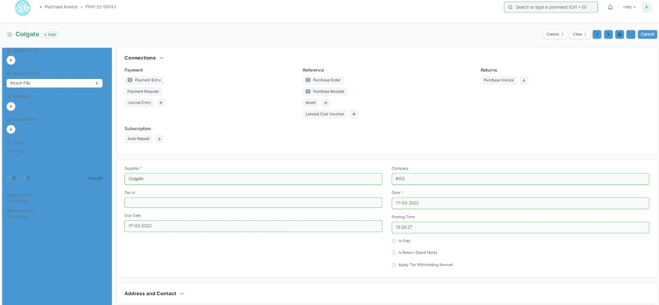

#### 21.4 Additional options when creating a Purchase Invoice

* Is Paid: You can tick 'Is Paid' if the amount has already been paid via an Advance Payment Entry. This should be ticked if there is full or partial payment.
* Is Return (Debit Note): Tick this if the customer has returned the Items.
* Apply Tax Withholding Amount: If the selected Supplier has a Tax Withholding Category set, this checkbox will be enabled. For more information, visit the Tax Withholding Category page.

#### 21.5 Statuses

* Draft: A draft is saved but yet to be submitted to the system.
* Return: The Items have been returned to the Supplier.
* Debit Note Issued: The Items have been returned and a Debit Note has been issued against the invoice.
* Submitted: The Purchase Invoice has been submitted to the system and the general ledger has been updated.
* Paid: Supplier has been fully paid the invoice amount and the corresponding Payment Entries have been submitted.
* Partly Paid: Supplier has been paid a part of the invoice amount and the corresponding Payment Entries have been submitted.
* Unpaid: The Purchase Invoice is yet to be paid.
* Overdue: The due date has passed for payment.

Cancelled: The invoice has been cancelled due to some reason.

1. ****Sales Entry****

A Stock Entry lets you record Item movement between Warehouses. To access the Stock Entry list, go to:

Home > Material management > Stock Transactions & Reports > Stock Entry

* Material Issue: If the material is being issued to someone in or outside the company (Outgoing Material). The Items will be deducted from the Warehouse set under Source Warehouse.
* Material Receipt: If the material is being received (Incoming Material). The Items will be added to the Warehouse set under Target Warehouse.
* Material Transfer: If the material is being moved from one internal Warehouse to another.
* Material Transfer for Manufacturing: If raw materials are being transferred for manufacturing. The transfer can happen against a Work Order or a Job Card.
* Material Consumption for Manufacture: There can be multiple consumption stock entries against a manufacturing Work Order. Refer this link for more details
* Manufacture: If the Material is being received from a Manufacturing/Production Operation.
* Repack: If the Original item/items are being repacked into new item/items.
* Send to Subcontractor: If the Material is being issued for a sub-contract activity. This entry is made from a Purchase Order.

### 22.1 Prerequisites

Before creating and using a Stock Entry, it is advised that you create the following first:

* Warehouse
* Item

#### 22.2 How to create a Stock Entry

Stock Entries for Manufacturing purposes are usually created from a Work Order. To create a Stock Entry manually for other purposes, follow these steps:

1. Go to the Stock Entry list, click on New.
2. Select the Stock Entry Purpose from the ones listed above.
3. If you set the Default Source or Target Warehouses, they'll be automatically filled for the rows in the Items table.
4. Source/Target Warehouses will be available as per the Stock Entry Purpose you selected.
5. Select Items and enter a quantity.
6. The basic rate will be fetched and the amount will be calculated automatically.
7. Save and Submit.

Usually, "Source Warehouse" and "Target Warehouse" both are set for recording a movement.

##### 22.2.1 Additional options when creating a Stock Entry

* Work Order: If this is a Manufacturing entry, the Work Order will be shown in this field.
* Edit Posting Date and Time: Will allow you to edit the Stock Entry's date and time.
* Inspection Required: If a Quality Inspection needs to be performed on the Items before submitting the Stock Entry.
* From BOM: If this is a Manufacturing entry, the associated BOM for the Item being manufactured will be shown.

#### 22.3 Stock Entry Type

You can also create a Stock Entry Type where only the name will be different, for example 'Scrap Entry'. The purpose will be Material Transfer but the name will be different. This is useful if you want certain Users to have access only to specific actions related to stock.

#### 22.4 Features

##### 22.4.1 The Items table

Details about the Item, Rate, Quantity, etc. will be shown here.

Ticking on 'Allow Zero Valuation Rate' will allow submitting the Purchase Receipt even if the Valuation Rate of the Item is 0. This can be a sample item or due to a mutual understanding with your Supplier.

Different Source and Target Warehouses can be set for different Items.

##### 22.4.2 Additional Costs

If the stock entry is an incoming entry i.e any item is receiving at a target warehouse, you can add related additional costs (like Shipping Charges, Customs Duty, Operating Costs, etc) associated with the process. The additional costs will be considered to calculate the Valuation Rate of the items.

To add additional costs:

1. Select the Expense Account to which the expense from this Stock Entry will be recorded.
2. Enter the description and amount of the cost in the Additional Costs table.

The added Additional Costs will be distributed among the receiving items (where the Target Warehouse mentioned) proportionately based on the Basic Amount of the items. And the distributed additional cost will be added to the basic rate of the item, to calculate Valuation Rate.

Quantity and Rate is shown as follows when you expand the Items table.

##### 22.4.3 Accounting Dimensions

You can tag different transactions based on different dimensions. By default, Projects can be considered as a dimension as it is a common practice to track costs of different projects.

##### 22.4.4 More Information

* Is Opening: If this entry is the opening stock entry for the Items.
* Remarks: Any additional remarks about the Item.
* Percentage Transferred: The percentage of Items transferred depending on Stock Entry purpose.
* Total Amount: The total amount of Items transferred.

##### 22.4.5 Perpetual Inventory

If the perpetual inventory system is enabled, additional costs will be booked in Expense Account mentioned in the Additional Costs table.

##### 22.4.6 After Submitting

After submitting a Stock Entry, you can go to the stock ledger or the accounting ledger from the dashboard.

1. ****Assets****

**An Asset is any valuable Item owned by a Company.**

Furniture, computers, mobile phones, printers, cars, manufacturing equipment are examples of assets. Generally, an asset is a tangible item that is located on the company premises or is carried by an employee. In some cases, an asset could be an intangible item.

An asset's useful life spans across multiple years and hence its economic value is spread over corresponding years from the accounting perspective. If you buy a printer for $300 and it is expected to be useful for three years, from the accounting perspective $100 is recorded as the expense for three years each instead of all the $300 in the first year. Most countries have rules for such calculations.

The Asset record is the heart of asset management module. All the transactions related to an Asset like purchasing, depreciation, maintenance, movement, scrapping, sales will be recorded against the Asset record.

Home > Material Management > Assets > Asset

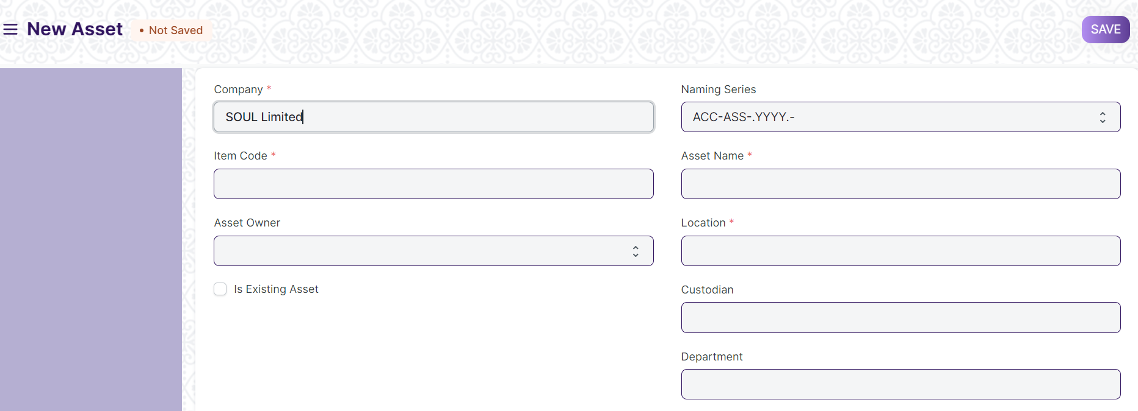

#### 23.1 Prerequisites

* [Item](https://docs.erpnext.com/docs/v13/user/manual/en/stock/item) with 'Is Fixed Asset' enabled.
* [Asset Category](https://docs.erpnext.com/docs/v13/user/manual/en/asset/asset-category)

#### 23.2 How to create an Asset

An Item representing the asset should be created. The **'Maintain Stock'** should be **unchecked** and **'Is Fixed Asset'** must be **checked**.

##### **23.2.1 Auto creation of assets**

You can automatically create assets on submission of Purchase Receipt by enabling **'Auto Create Assets on Purchase'** in Item.

If you have enabled auto asset creation for the item representing an asset, you will have to provide the asset location while submitting the Purchase Receipt.

A message confirming the creation of assets is displayed on submission of Purchase Receipt.

##### **23.2.2 Manual creation of assets**

If you would like to create assets manually, create an Item with 'Is Fixed Asset' enabled and leave 'Auto Create Assets on Purchase' unchecked . On submission of a Purchase Receipt/Purchase Invoice with that Item a message is shown indicating that you need to create assets manually.

Follow below steps to create assets manually.

1. Go to the Assets list, click on New.
2. Enter a name for the asset.
3. Select the Item Code. Item Name and Asset Category will be fetched automatically.
4. Select the Asset Owner, i.e. Company, Supplier, or Customer.
5. Select the Company/Supplier/Customer.
6. Select the Purchase Receipt/Purchase Invoice. Purchase Date and Gross Purchase Amount will be fetched automatically.
7. Select a Location. Eg: Mumbai Office. This will be fetched automatically if specified in Purchase Receipt items table
8. Set Available-for-use Date. The depreciation will be calculated starting from this date.
9. Click on Save and Submit.

Please note you need create **one asset record for each asset you have bought**. If you have bought five computers and have created just one Purchase Receipt with quantity set to five then you will have to create five asset records manually.

##### **23.2.3 Importing existing assets**

You will have to add details of all the assets your company has purchased previously along with depreciation details of each asset.

For an existing asset, you can create the asset record directly by checking **"Is Existing Asset"** checkbox and provide below details.

* Gross Purchase Amount
* Purchase Date
* Available-for-use Date
* Opening Accumulated Depreciation: The accumulated depreciation amount which has already been booked for an existing asset.
* Number of Depreciations Booked: Number of depreciation entries already booked.

Based on these details the schedule for depreciation of remaining amount will be created automatically.

##### **23.2.4 Additional options when creating an Asset**

1. ****Custodian****: The employee who will carry the asset.
2. ****Department****: The department of the Custodian.
3. ****Next Depreciation Date****: Mention the next depreciation date, even if it is the first one. If the asset is an existing one and depreciation has already been completed, leave it blank.
4. ****Calculate Depreciation****: Enable this checkbox to calculate depreciation of Assets.
5. ****Allow Monthly Depreciation****: Enable this checkbox to distribute depreciation amount of an asset into 12 months of the year. Depreciation entries will be made every month on the date provided as Depreciation Start Date. For example, if Available for Use date is 22nd Nov 2019 and depreciation Start Date is 31st March 2020, first depreciation will be done on 30th Nov 2019 second on 31st Dec 2019 and so on. Amount will be distributed based on days left until next depreciation.

#### **23.3. Features**

##### **23.3.1 Depreciation**

* ****Frequency of Depreciation (Months)****: The number of months between depreciations.
* ****Total Number of Depreciations****: The total number of depreciations during the useful life of the Asset. In case of existing assets which are partially depreciated, mention the number of pending depreciations. For example, if you set frequency as 12 months and no. of depreciations as 3, 1 depreciation will be booked every 12 months for 3 years.
* ****Depreciation Method****: These are three methods used for depreciation :
  + ****Straight Line****: This method spreads the cost of the fixed asset evenly over its useful life.
  + ****Double Declining Method****: An accelerated method of depreciation, it results in higher depreciation expense in the earlier years of ownership.
  + ****Written Down Value****: In this method, the depreciation percentage is fixed but it is applied on the current value of the asset which we get after each depreciation.
* ****Depreciation Start Date****: The date from which booking of depreciation will be started.
* ****Expected Value After Useful Life****: Useful Life is the time period over in which the company expects that the asset will be productive. After that period, either the asset is scrapped or sold. In case it is sold, mention the estimated value here. This value is also known as Salvage Value, Scrap Value, or Residual Value.
* ****Rate of Depreciation****: This will be calculated based on the amount entered in expected value after useful life.

##### **23.3.2 Depreciation Schedule**

On booking depreciations against this Asset, the Depreciation Schedule section will be visible. This table has columns for Finance Book, Schedule Date, Depreciation Amount, Amount Depreciated, and Journal Entry.

##### **23.3.3 Insurance Details**

If Insurance has been taken for the Asset you're recording, you can store the following Insurance details:

* Policy number
* Insurer
* Insured value
* Insurance Start Date
* Insurance End Date
* Comprehensive Insurance

##### **23.3.4 Accounting Entries**

On submission of an asset, "Capital Work in Progress" account will be credited and the asset account related to the asset will be debited. Submission is only possible after entering "Available-to-use Date". If "Available-to-use Date" is a future date, then accounting entry will be booked automatically on that date via the scheduler.

##### **23.3.5 Maintenance**

Ticking on Maintenance Required allows recording Asset Maintenance entries for this Asset.

##### **23.3.6 After Submitting**

Once you create an Asset, you'll see options to transfer, scrap, or sell the asset. From the Make button, you can adjust its value and make a depreciation entry.

1. ****Location****

**Asset Location shows where an Asset is located.**

The assets that your organization owns can be located at various facilities like administrative offices, manufacturing plants, warehouses, etc. You can create a 'Location' for each of your facilities and track the assets which are present in these locations.

You can also add Latitude and Longitude of the location. When an asset is moved from one location to another, you need to create an Asset Movement record.

Home > Material Management > Assets > Location

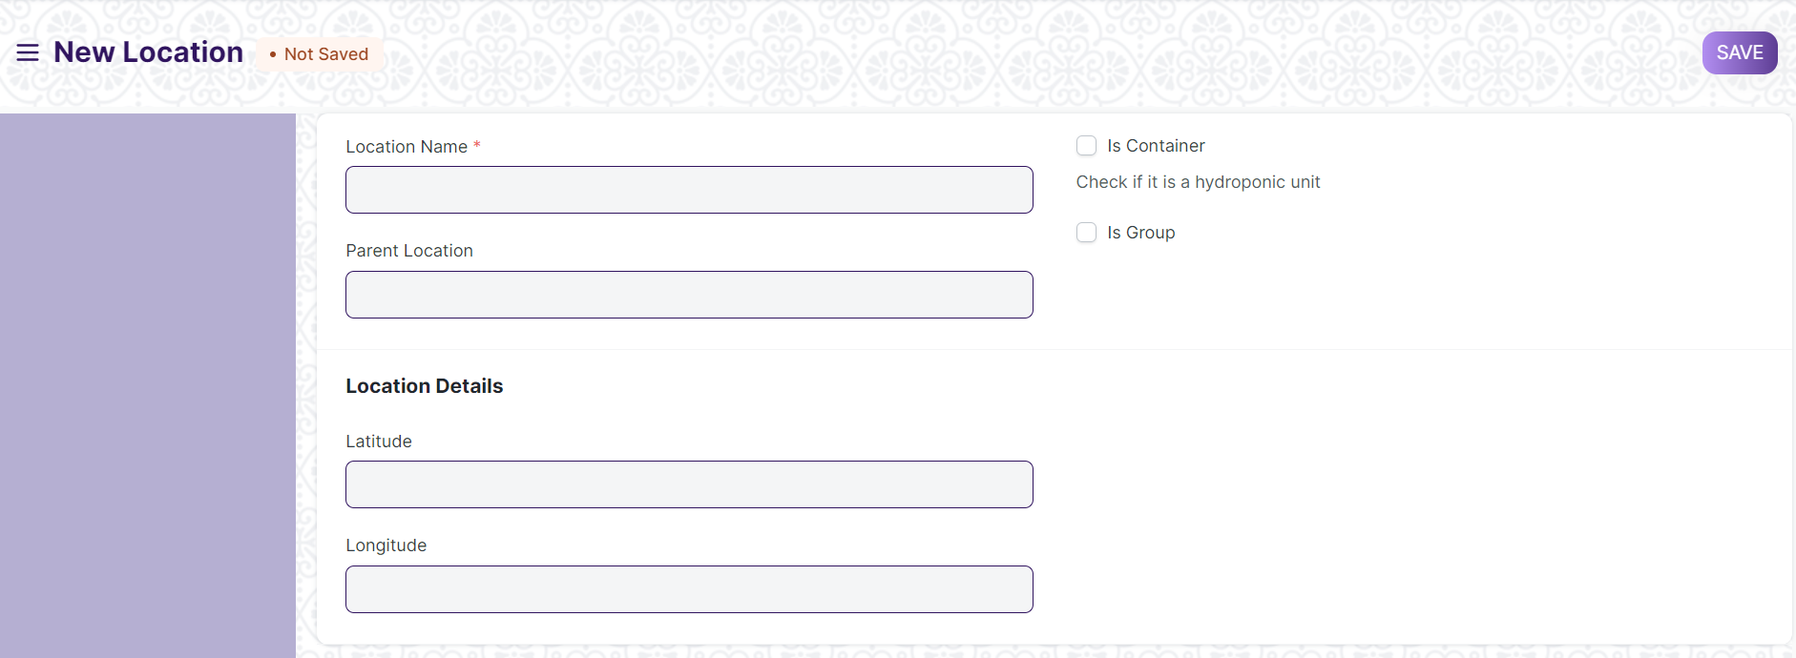

1. ****Asset Category****

**An Asset Category classifies different assets of a Company.**

The first step towards asset management is creating an Asset Category based on the type of assets. For example, all your desktops and laptops can be part of an Asset Category named "Electronic Equipments".

In Asset Category, you can set default a depreciation method, periodicity and depreciation related accounts, which will apply to all the assets under the category.

Home > Material Management > Assets > Asset Category

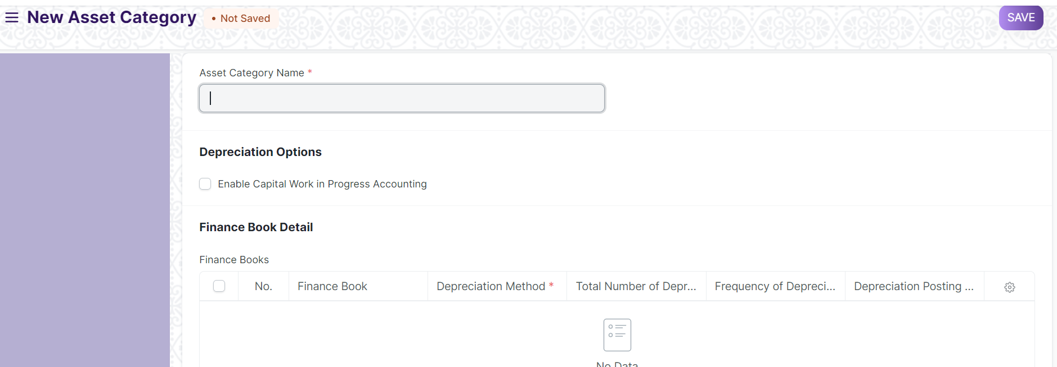

#### **25.1 How to create an Asset Category**

1. Enter a name for the Asset Category.
2. Check 'Enable Capital Work in Progress Accounting' if you want to maintain records of assets under a temporary balance sheet account instead of the corresponding asset account.
3. Click on Save

##### **25.1.1 Additional options when creating an Asset Category**

1. ****Enable Capital Work in Progress Accounting****: On enabling this, accounting entry for assets under this category which are not in use are posted in the Capital Work in Progress accounts. This happens when you own the Asset but it isn't being used yet, i.e. 'Available for Use Date' is set at a later date. If you use all your assets immediately, disable this feature. On disabling this, CWIP accounting will be skipped.

#### **25.2 Features**

##### **25.2.1 Finance Book details**

You can link a Finance Book if you report depreciation in different ways. You can enter the following fields:

* ****Depreciation Method****: Choose a depreciated method on which you'll record the depreciation of assets in this category.
* ****Frequency of Depreciation (Months)****: The number of months within which the depreciation will be booked. The asset may be scrapped after this period.
* ****Total Number of Depreciations****: The number of deprecations to be booked in the selected time frame.
* ****Rate of Depreciation****: The rate of deprecation applied over the selected period. This will be calculated based on the Depreciation Method selected.

##### **25.2.2 Accounting Details**

The following account details can be set to record asset values in the ledger:

* Company
* Fixed Asset Account
* Accumulated Depreciation Account
* Depreciation Expense Account
* Capital Work In Progress Account

1. ****Asset Movement****

**Asset Movement refers to moving an Asset from one Location to another.**

You can track the location of an asset or to whom it is issued. For tracking, you need to create an Asset Movement transaction, whenever the asset is moved from one location to another. You can also keep a track of issuance of an asset to any employee.

Home > Material Management > Assets > Asset Movement

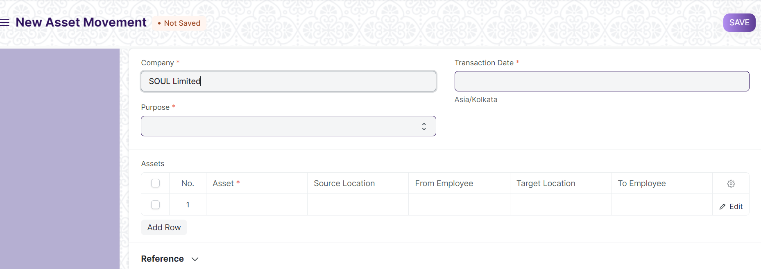

#### **26.1 Prerequisites**

* Asset
* Asset location

#### **26.2 How to create an Asset Movement**

1. Go to the Asset Movement list, click on New.
2. Select the Purpose from 'Issue', 'Receipt', or 'Transfer'. Mandatory fields will be changed based on purpose.
3. Select a date.
4. Select Assets you want to move. Current Location / Custodian will be automatically fetched.
5. Select Reference Document Type (Optional).
6. Select Reference Document Name (Optional).
7. Click on Save and Submit

To make an Asset Movement of a number of assets, it is advised to go to Asset List, select assets to be moved and click on **Make Asset Movement** from Actions menu on the top left.

There is also a **Transfer Asset** button on the top right of the Asset form to initiate Asset Movement. It auto fills available fields from Asset Form.

1. ****Asset Maintenance Team****

**The Asset Maintenance Team is responsible for carrying out maintenance activities on the Asset.**

The maintenance activities can be cleaning, polishing, servicing, or any other activity required to maintain the Asset in good condition.

Home > Material Management > Maintenance > Asset Maintenance Team

#### **27.1 Prerequisites**

* Employee
* Asset

#### **27.2 How to create an Asset Maintenance Team**

1. Go to the Asset Maintenance Team list, click on New.
2. Enter a name for the team.
3. Select a manager for the team.
4. In the Maintenance Team Members table, add the team members and select their maintenance [roles](https://docs.erpnext.com/docs/v13/user/manual/en/setting-up/users-and-permissions/role-and-role-profile).
5. Save.
6. ****Asset Maintenance****

**Asset Maintenance refers to any activity done on Assets to maintain their performance or condition.**

To track the details of individual maintenance/calibration tasks for an asset by date, the person responsible for the maintenance, and future maintenance due date.

To perform Asset Maintenance:

1. Enable 'Maintenance Required' from the Asset master.
2. Create an Asset Maintenance Team.
3. Create the Asset Maintenance.
4. An Asset Maintenance Log is created.
5. Create Asset Repair Log.

Home > Material Management > Maintenance > Asset Maintenance

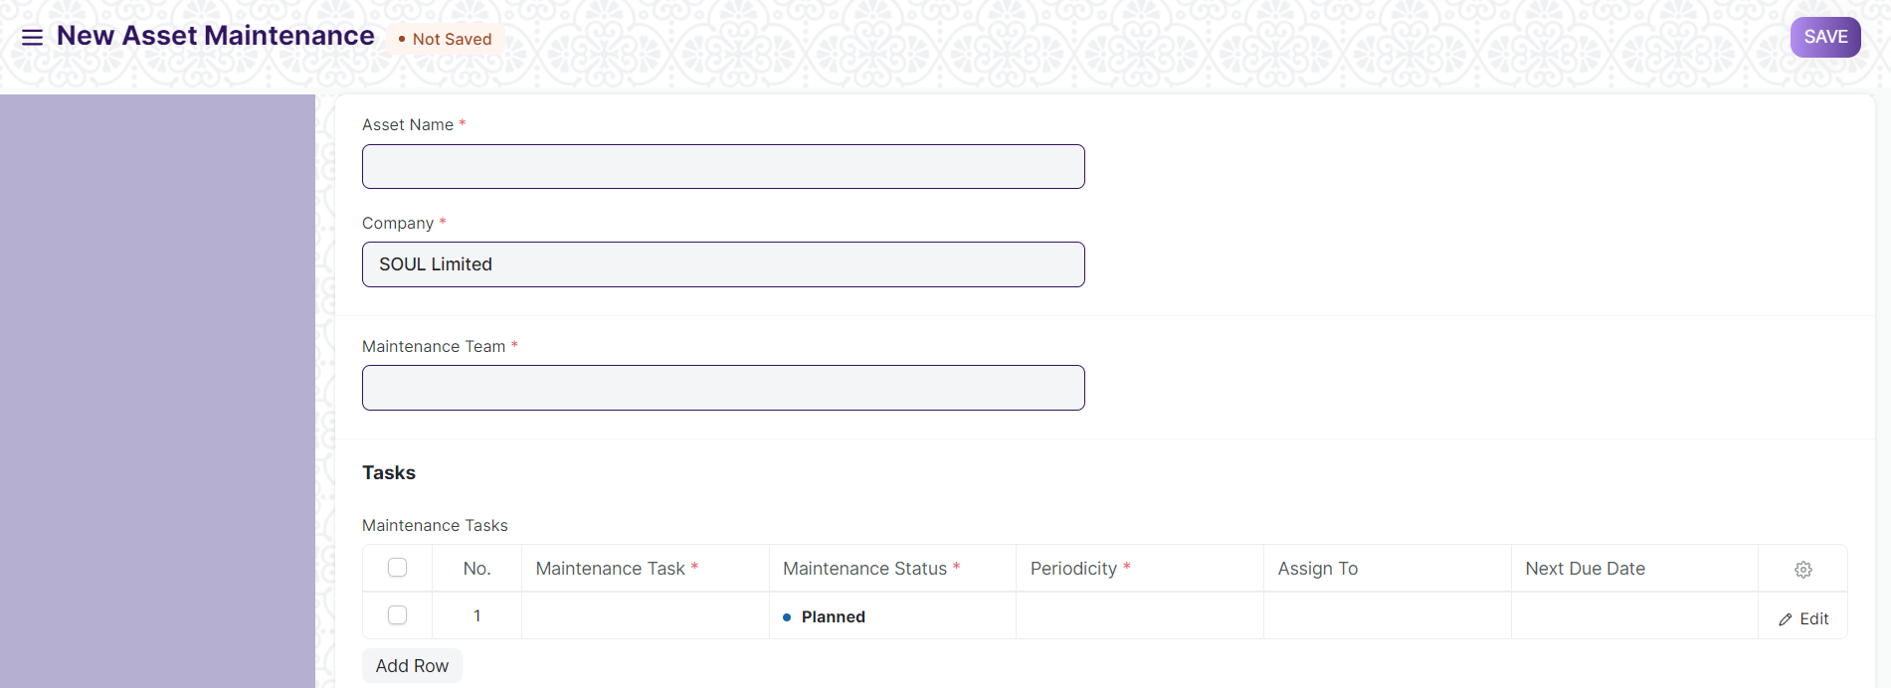

#### **28.1 Prerequisites**

* Asset with ‘Maintenance Required’ Checked
* Asset Maintenance Team

#### **28.2. How to create Asset Maintenance**

For each asset, create an Asset Maintenance record listing all the associated maintenance tasks, maintenance type (Preventive Maintenance or Calibration), periodicity, assign to and start and end date of maintenance

1. Go to the Asset Maintenance list, click on New.
2. Select the Asset.
3. Select the Asset Maintenance Team.
4. Add Maintenance Tasks in the table.
5. Set the Maintenance Status whether 'Planned', 'Overdue', or 'Canceled'.
6. Select a periodicity for which the task needs to be carried out. The next due date will be calculated.
7. Save.
8. After saving, you can assign the task to a user.
9. If the Item is serialized, the Serial Number can be entered.

#### **28.3 Features**

##### **28.3.1 Maintenance Tasks**

* ****Maintenance Type****: Whether this is a 'Preventive' maintenance activity or 'Calibration' to restore accurate functioning.
* ****Start and End Date****: Set the start date and end date when the maintenance is supposed to begin and end.
* ****Last Completion Date****: If the maintenance was not carried out on or before the scheduled date, the actual date of maintenance can be recorded here.

1. ****Asset Maintenance Log****

**Asset Maintenance Log logs the tasks carried out in an Asset Maintenance.**

For each task in Asset Maintenance, Asset Maintenance Log is **auto created** to keep track of the upcoming maintenances. It will have a status, completion date and actions performed. Based on completion date here, next due date is calculated automatically and new Asset Maintenance Log is created.

Home > Material Management > Maintenance > Asset Maintenance Log

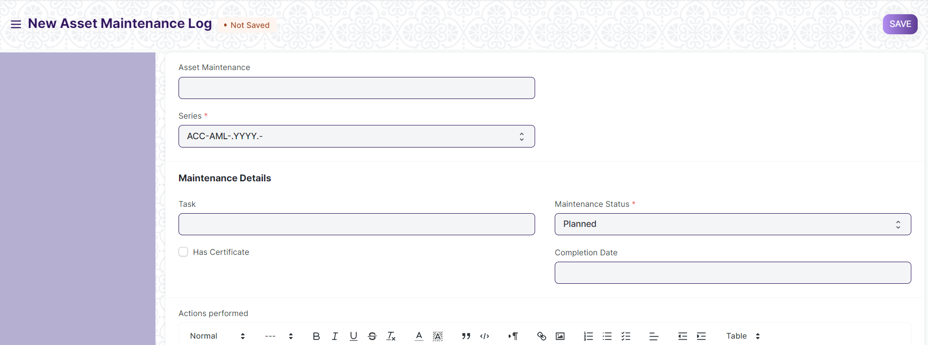

#### **29.1 Prerequisites**

* Asset Maintenance

#### **29.2 Options in Asset Maintenance Log**

A Draft of the Asset Maintenance Log is created as scheduled in the Asset Maintenance form. In order to submit an Asset Maintenance Log, the Asset Maintenance status has to either 'Completed' or 'Canceled'.

* The status of the Asset Maintenance Log can be 'Planned', 'Completed', 'Canceled', or 'Overdue'.
* Additional notes can be added in the Actions performed section to describe the activity in detail.

1. ****Asset Repair****

**Asset Repair refers to any activity carried to repair a broken Asset to restore full functionality.**

You can also maintain the records of Repair/Failures of Assets which are not listed in Asset Maintenance.

Home > Material Management > Maintenance > Asset Repair

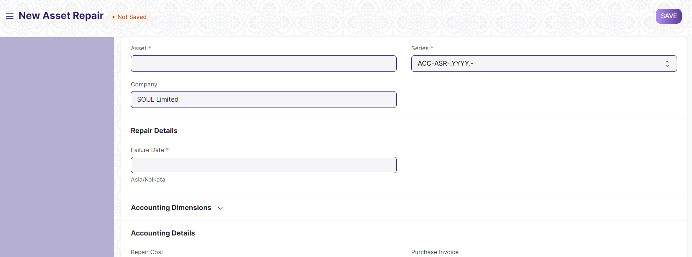

#### **30.1 Prerequisites**

* Asset

#### **30.2 How to create an Asset Repair**

1. Go to the Asset Repair list, click on New.
2. Select the Asset.
3. Select the Failure Date.
4. Enter the Repair Cost.
5. Click on Save.
6. Change the Repair Status from 'Pending' to 'Completed', or 'Canceled'.
7. Select a Purchase Invoice if Repair Cost is greater than zero.
8. Click on Save and Submit.

##### **30.2.1 Additional options when creating an Asset Repair**

* ****Capitalize Repair Cost****: If checked, the Repair Cost will be added to the Asset's value. This could also allow you to increase the Asset's life.
* ****Increase In Asset Life(Months)****: The number of months by which the Asset's life might be extended by the repair can be added here. This will modify the Depreciation Schedule of the Asset. This field will only be visible if Capitalize Repair Cost is checked.
* ****Stock Consumed During Repair****: Checking this will allow you to make a note of all the Stock Items consumed during the repair.
* ****Warehouse****: The Warehouse from which the Stock Items consumed during the repair were taken should be entered here, if Stock Consumed During Repair is checked.
* ****Stock Items****: Entering Stock Items consumed during the repair here will create a Stock Entry record of type Material Issue for them, thereby decreasing their quantity. GL Entries will also be created for each Item in the table. This table will only be visible if Stock Consumed During Repair is checked. In case of Serialized Items, the Item row can be expanded to reveal the Add Serial No button.
* ****Error Description****: A detailed descripton of the problem can be entered here.
* ****Actions Performed****: A sequence of actions performed to carry out the repair can be noted down here.

#### **30.3 Features**

##### **30.3.1 Accounting Dimensions**

Accounting Dimensions let you tag transactions based on a specific Territory, Branch, Customer, etc. This helps in viewing accounting statements separately based on the selected dimension(s).

##### **30.3.2 Purchase Invoice**

A Purchase Invoice can be linked with the Asset Repair, to account for any Items that need to be purchased to carry out the repair or the repair service offered.

##### **30.3.3 Total Repair Cost**

If Stock Consumed During Repair is checked, the Total Repair Cost will be computed based on the value of the consumed Stock Items and the Repair Cost entered.

1. ****Serial No****

As discussed in the Item page, if an Item is *serialized*, a Serial Number (Serial No) record is maintained for each quantity of that Item. This information helps track the location of the Serial No, it’s warranty and end-of-life (expiry) information.

Serial Nos are also useful to maintain fixed assets. Maintenance Schedules can also be created against Serial Numbers for planning and scheduling maintenance activity for these assets (if they require maintenance).

You can also track from which Supplier you purchased the Serial No and to which Customer you have sold it. The Serial No status will tell you its current inventory status.

If your Item is *serialized,* you will have to enter the Serial Nos in the related column with each Serial No in a new line. You can maintain single units of serialized items using Serial Number.

To access the Serial Number list, go to:

Home > Material Management > Serial No and Batch > Serial No

**31.1 Prerequisites**

Before creating and using a Serial Number, it is advised that you create the following first:

* Item
* Enable 'Has Serial No' in the Item master

#### 31.2 How to create a Serial Number

Usually, Serial Numbers are auto-created when transactions are made against a serialized Item. This works only when 'Has Serial No' is enabled and a series is set in the Item master.

For example, a series was set for the following Item as 'PB2L.#####'. Then a Stock Entry was submitted to receive the Item. The Serial Numbers were created accordingly.

However, if you want to create a Serial No *manually* follow these steps:

1. Go to the Serial Number list, click on New.
2. Enter a Serial Number.
3. Enter the Item Code and details will be fetched.
4. If any transaction is done with an item, Serial No cannot be set or unset.
5. Click on Save.

Inventory of an Item can only be affected if the Serial No is transacted via a Stock transaction (Stock Entry, Purchase Receipt, Delivery Note, Sales Invoice). When a new Serial No is created directly, its Warehouse cannot be set.

##### 31.2.1 Notes about Serial Number

* The Status is set based on Stock Entry.
* Only Serial Numbers with status 'Available' can be delivered.
* Serial Nos can automatically be created from a Stock Entry or Purchase Receipt. If you mention Serial No in the Serial Nos column, it will automatically create those serial Nos.
* If in the Item Master, the Serial No Series is mentioned, you can leave the Serial No column blank in a Stock Entry / Purchase Receipt. Serial Nos will automatically be set from that series.

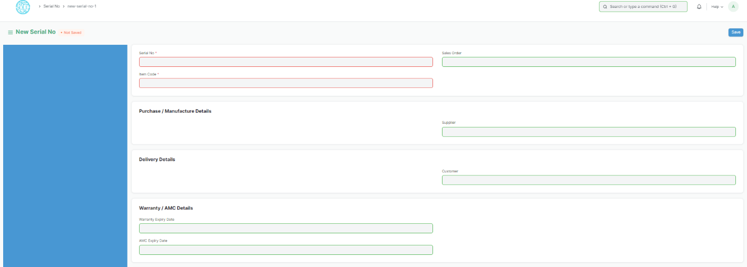

#### 31.3 Features

##### 31.3.1 Purchase/Manufacture details

The document from which the Serial No was created will be shown. If you purchased it from

a Supplier, it'll be linked here.

##### 31.3.2 Delivery Details

If the Serial No was generated from a Sales Order, the Customer will be linked here.

##### 31.3.3 Warranty/AMC Details

If the Item is under warranty or AMC (Annual Maintenance Contract), the expiry dates for

these can be set.

##### 31.3.4 More Information

Any additional information about this specific Item unit can be set under 'Serial No Details'.

1. ****Batch****

Batch feature allows you to group multiple units of an Item and assign them a unique

value/number/tag called Batch No.

This is done based on the Item. If the Item is batched, then a Batch number must be mentioned in every stock transaction. Batch numbers can be maintained manually or automatically. This feature is useful to set the expiry date of multiple Items or move them together to different Warehouses.

Home > Material Management > Serial No and Batch > Batch

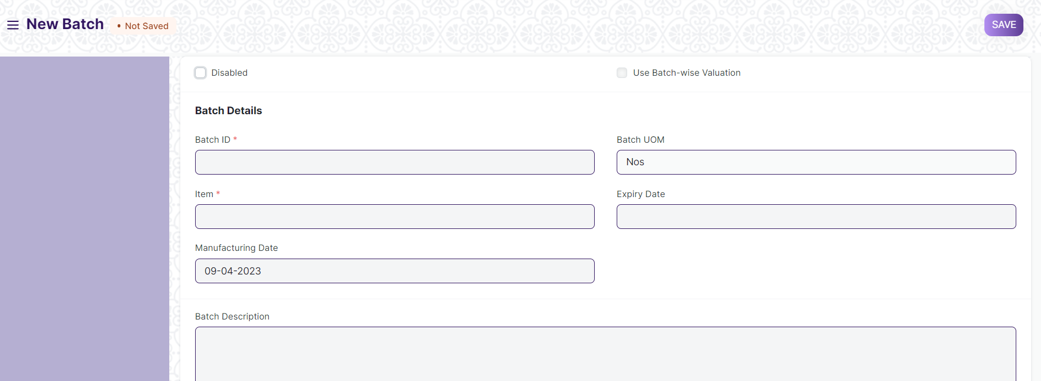

**32.1 Prerequisites**

* [Item](https://docs.erpnext.com/docs/v13/user/manual/en/stock/item)
* Enable 'Has Batch No' in the Item master

#### **32.2 How to create a new Batch**

To set item as a batch item, "Has Batch No" field should be checked in the Item master. If you have not selected "Automatically Create New Batch" when creating an Item, you will have to make Batches Manually as you go along.

To create new Batch No. master for an item, go to:

1. Go to the Batch list, click on New.
2. Set the Batch ID.
3. Select the Item.
4. If any transaction is done with an item, the batch cannot be set or unset.
5. Save.

When Batches are enabled for an Item, the option to [retain sample stock](https://docs.erpnext.com/docs/v13/user/manual/en/stock/retain-sample-stock) also becomes available.

##### **32.2.1 Batch Auto Creation**

If you want automatic batch creation at the time of Purchase Receipt, you must tick 'Automatically Create New Batch' in the Item master:

#### **32.3 Features**

##### **32.3.1 Splitting and Moving Batches**

When you open a batch, you will see all the quantities that belong to that batch on the page.

* To move the batch from one Warehouse to another, you can click on the **Move** button.
* You can also split the batch into smaller one by clicking on the **Split** button. This will create a new Batch based on this Batch and the quantities will be split between the batches.
* If you set expiry date, the Batch will show 'Not Expired' until the expiry date, after which it'll show 'Expired'. If a date is not set, the Batch will show 'Not Set'.

##### **32.3.2 Transacting Items with Batches**

A Batch master should be created before the creation of Purchase Receipt. Hence, every time a Purchase Receipt or Work Order is being made for a batch item, you will first create its Batch No, and then select it in the Purchase order or Stock Entry.

On every stock transaction (Purchase Receipt, Delivery Note, Invoice) with a batch item, you should provide the Item's Batch No.

1. ****Stock Settings****

You can set default settings for your stock related transactions from the Stock Settings page.

**33.1. Item Naming By**

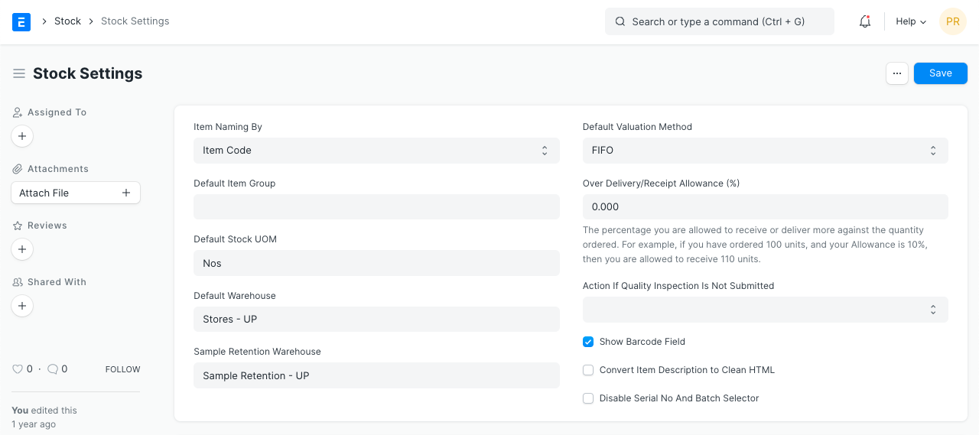

By default, the Item Name is set as per the Item Code entered. If you want Items to be named by a set [Naming Series](https://docs.erpnext.com/docs/v13/user/manual/en/setting-up/settings/naming-series) choose the 'Naming Series' option .

**33.2. Defaults**

**33.2.1 Default Item Group**

This will be the default item group allocated to a newly created item. Item groups are useful for classification and setting properties for the whole group. To know more visit the Item Group page.

**33.2.2 Default Stock UOM**

The default unit of measure for stock is set as numbers (Nos), it can be changed from here.

**33.2.3 Default Warehouse**

Set the default Warehouse from which the stock transactions are done. This will be fetched into the Default Warehouse in the Item master: 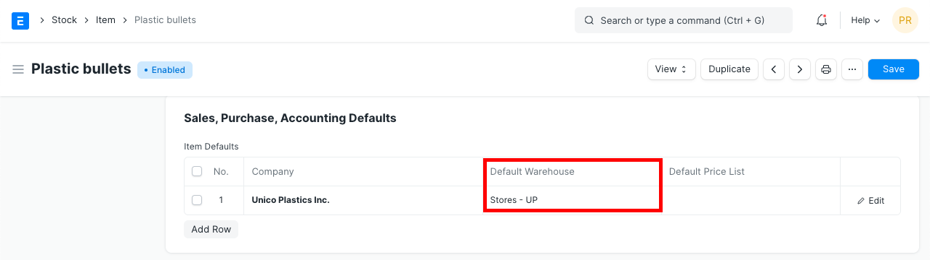

**33.2.4 Sample Retention Warehouse**

This is the Warehouse where sample retention's are stored.

**33.2.5 Default Valuation method**

FIFO - first in first out or moving average valuation for your items. The default method is FIFO. If you select Moving Average, new Items will be valuated on Moving Average. You can change this when creating new Items in the Item form. Once the Item is saved, the Valuation Method cannot be changed.

**33.3. Limit Percent**

This is the percentage you are allowed to receive or deliver more against the quantity ordered. For example: If you have ordered 100 units, Supplier sends 120 units and the percentage is set to 10% then you are allowed to receive 110 units. By default, this is set to 0.

**33.4. Role Allowed to Over Deliver/Receive**

Users with this role are allowed to over deliver/receive against orders above the allowance percentage

**33.5. Show Barcode Field**

A field to enter Barcode details for an item. If unticked, the field won't be visible in the Item form.

**33.6. Convert Item Description to Clean HTML**

Usually, descriptions are copy-pasted from a website or Word/PDF file and they contain a lot of embedded styles. This messes up the Print view of your invoices or quotes.

To fix this, you can check "Convert Item Description to Clean HTML" in Stock Settings. This will ensure that when you save the Items, their descriptions will be cleaned up.

If you want to control your description, views, and allow any HTML to be embedded, you can uncheck this property.

**33.7. Auto insert**

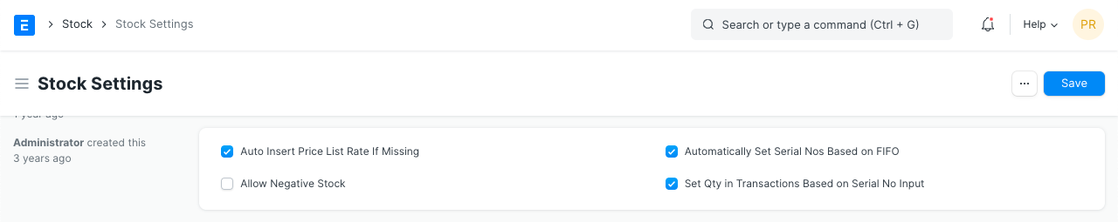

**33.7.1 Auto insert Price List rate if missing**

Enabling this will insert an Item Price to the Price List of an Item automatically when using the Item in its first transaction. This price is fetched from the 'Rate' set in the first transaction with the Item. The Price List depends on whether you're using a Purchase or Sales transaction.

Note that, the Item Price will be automatically inserted only in the first transaction if not already present.

If this is unticked, the 'Standard Selling Rate' set in the Item when creating the Item will be added as Item Price.

**33.7.2 Automatically Set Serial Nos based on FIFO**

Serial numbers for stock will be set automatically based on the Items entered based on first in first out. The Serial Numbers will be set automatically in transactions like Purchase/Sales Invoices, Delivery Notes, etc.

**33.8. Allow Negative Stock**

This will allow stock items to be displayed in negative values. Using this option depends on your use case. For example, the stock transaction entries are entered at the weekend or month-end. In this case, negative stock needs to be enabled so that you can continue with your purchase/sales transaction entries.

**33.9. Set Qty in Transactions based on Serial No Input**

The quantity of items will be set according to the serial numbers. For example, if the user has added serial nos like A001, A002, and A003 then the system will set the quantity as 3 in the transaction.

**33.10. Automatic Material Request**

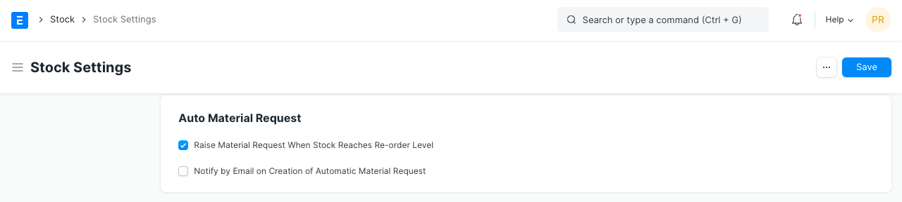

**33.10.1 Raise Material Request when the stock reaches re-order level**

This option is useful if you want to ensure a constant supply of raw materials/products and avoid shortage. A Material Request will be raised automatically when stock reached the re-order level defined in the Item form.

**33.10.2 Notify by Email on the creation of automatic Material Request**

An email will be sent to notify the User with the role 'Purchase Manager' when an automatic Material Request is created.

**33.11. Inter Warehouse Transfer Settings**

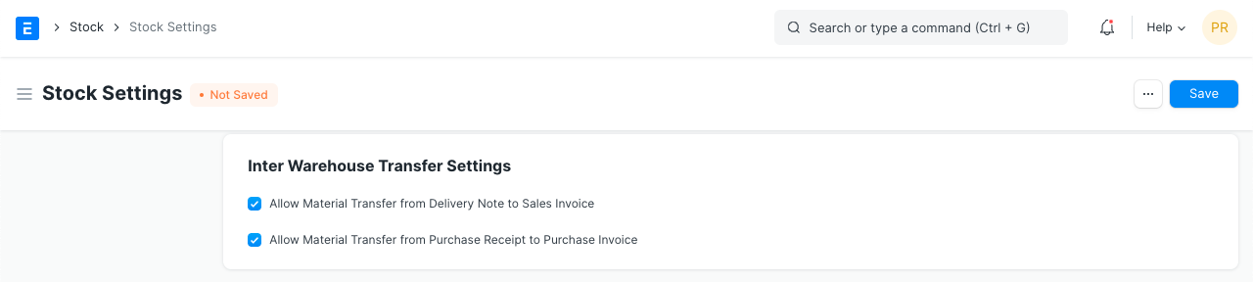

**33.11.1 Enable customer warehouse for material transfer from Delivery Note and Sales Invoice**

This option is useful when material transfer needs to be presented as a Delivery Note. For example, if there are statutory requirements where taxes are to be applied on each transfer of Material. It is easier to manage in a transaction like Delivery Note, than in the Stock Entry

**33.11.2 Enable supplier warehouse for material transfer from Purchase Receipt and Purchase Invoice**

Similar to above option this option is useful when material transfer needs to be presented as Purchase Receipt.

To know more about inter warehouse material transfer via Delivery Note and Purchase Invoice please refer this article Material Transfer From Delivery Note

**33.12. Freeze Stock Entries**

The User will not be allowed to make stock postings beyond this date.

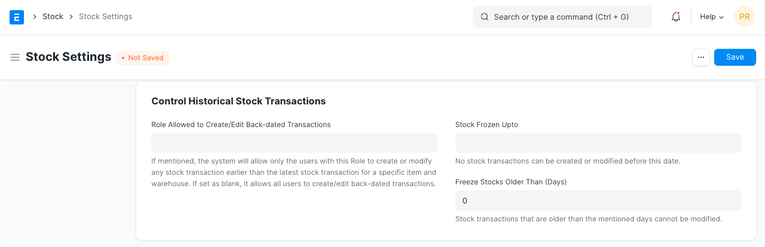

* ****Stock Frozen Upto****: A threshold date till which stocks will be frozen.
* ****Freeze Stocks Older Than [Days]****: Stocks older than x days will be frozen. This is calculated based on the creation date of the item.
* ****Role Allowed to edit frozen stock****: The role you choose here will be allowed to edit frozen stock.

1. ****Stock Summary****

**Stock Summary report is a detailed report of Total stock present across different warehouses.**

**It all Items present in different warehouses, their description and current quantity.**

Here is how Stock Summary report looks like:

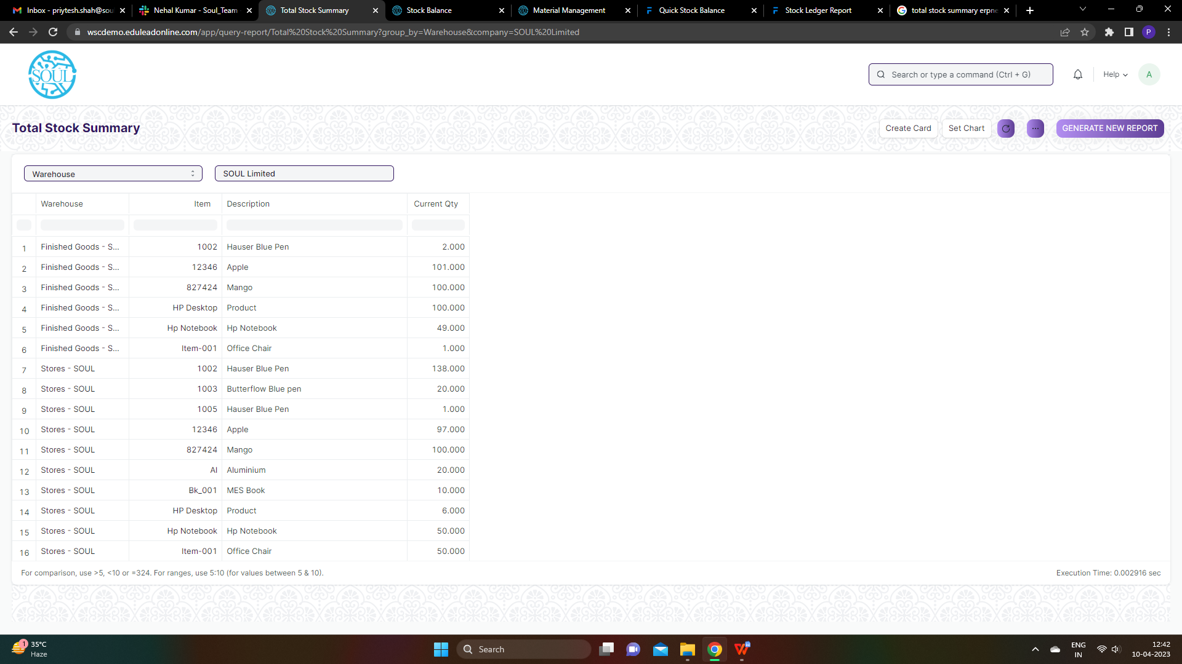

1. ****Stock Ledger****

**A Stock Ledger Report is a detailed record that keeps track of stock movements for a company.**

Inward or outward transactions related to Manufacturing, Purchasing, Selling, and Stock Transfers are recorded in the Stock Ledger which then is reflected in the Stock Ledger Report.

It reflects the quantity and value of stock ****issued, received, or transferred**** along with the stock item and its warehouse details.

It can be referred when the ****Perpetual Inventory**** system is enabled, as this report reflects the history of all your stock transactions. It presents a more granular view of the stock transactions.

**Stock Ledger Report Attributes**

**Incoming Rate:** It reflects the actual value of the stock at which it was brought under your inventory. It reflects the same value as entered in the Rate field of the document.

**Balance Value:** It represents the total value of the remainder stock in the inventory. It is the product of Valuation Rate and Balance Quantity of a stock item.

**Valuation Rate:** It is calculated based upon the valuation method selected.

Here is how Stock Ledger Report represents a ****Stock Entry**** of type Material Receipt.

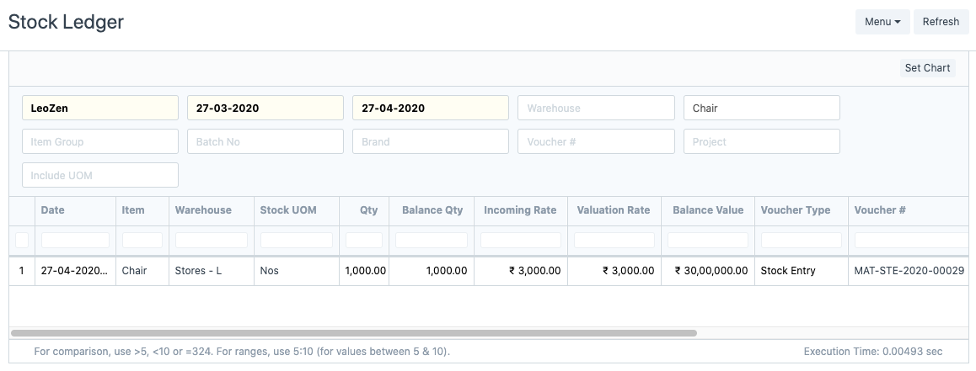

1. ****Stock Balance****

Stock Balance report is a detailed report showing details regarding the balance of Item wise stock in different warehouses.

**Stock Balance Report Attributes**

**Balance Qty:** It reflects the total no of items left in the warehouse.

****Balance Value****: It represents the total value of the remainder stock in the inventory. It is the product of Valuation Rate and Balance Quantity of a stock item.

**Opening Qty:** It reflects Opening quantity of item in the warehouse during Opening stock entry.

**Opening Value:** It represents the total value of the stock during stock opening.

**In Qty:** It reflects total number of stocks brought to any warehouse.

**In value:** It represents the total value of the stock during the In transaction.

**Out Qty:** It reflects total number of stocks transferred from any warehouse.

**Out value:** It represents the total value of the stock transferred from any warehouse.

****Valuation Rate****: It is calculated based upon the valuation method selected.

**Reorder Level:** It reflects the total number of item that need to be checked while reordering an Item.

**Reorder Qty:** It reflects the total number of items to be reordered.

Here is how Stock Balance Report looks like:

